Software Requirements Specification
for
DecidR
Version: | 0.6
Author(s): | MF, DH
Created: | 02/14/2009

Version | Date | Author(s) | Changes
0.1 | 13/12/2008 | MF | Initial version.
0.2 | 12/16/2008 | MF | Changed to current design.  Added chapter „modeling semantics“
0.3 | 1/26/2009 | MF, DH | Merged existing documents into one.  Finished first draft of non-functional requirements.
0.3 | 1/29/2009 | MF, DH | Worked on non-functional requirements.
0.4 | 1/29/2009 | DH | Completed preliminary version of design constraints section, made minor additions to non-functional requirements.
0.4 | 1/29/2009 | DH,MF | Reviewed chapters 2 and 6 with Markus via Skype.
0.5 | 2/2/2009 | DH | Fixed grammar in introduction after Thomas’ feedback. Updated “tools” section in design constrains and “integrated help” section after feedback from client. Changed e-mail attachment size to 50 MB.
0.5 | 2/13/2009 | DH | Cleaned up formatting, moved Draw2D to assumptions, removed MVC framework design constraints (if we get in trouble due to that we’re hosed), updated quantity structure.
0.6 | 2/14/2009 | MF | Modeling Semantics and UI Integrated

Contents
Introduction 7
Purpose 7
Document Conventions 7
Intended Audience and Reading Suggestions 7
References 8
Internal documents 8
External documents 8
Product Scope 9
Overall Description 10
Product Perspective 10
Product Functions 10
User Classes and Characteristics 11
Super Administrator 11
Tenant Administrator 11
Workflow Administrator 12
Workflow Participant 12
Operating Environment 12
Design and Implementation Constraints 14
Third Party Components & Libraries 14
Interfaces to other applications 14
Technologies & Standards 14
Frameworks & APIs 14
Java Persistence API (JPA) 14
Infrastructure 14
Tools 14
Language Requirements 14
Programming Standards 14
User Documentation 15
Installation Guide 15
Integrated Help 15
Extension Guide 15
Assumptions and Dependencies 15
User Interface 16
Overview 16
Public Welcome Page 16
Logged in View 17
User Pages 19
Workitems 19
Profile Settings 20
Change Tenant 21
Workflow Admin Pages 22
Create Instance 22
Show Workflow Instances 23
Show Userlist 24
Tenant Admin Pages 25
Create / Edit Workflow Models 25
Tenant settings 27
Edit Userlist 29
Super Admin Pages 30
Edit Tenants 30
Approve Tenants 31
System Settings 32
Show /Edit Users 33
Modeling Tool and Modeling Semantics 34
Overview 34
The Modeling Tool 35
Toolbar Elements 35
Variables List 36
Role list 36
Property Window 36
Activities 37
Start activity 37
End activity 37
Email Web Service activity 37
Human Task Web Service activity 37
Containers 38
Flow container 38
If container 39
For each container 40
The DecidR Workflow Definition Language (DWDL) 40
Header 41
Root element 41
Inline documentation 41
Variables list 41
Fault Handler 42
Nodes 42
Arcs 43
Introduction to System Features 45
Actors 45
User 45
Unregistered User 45
Registered User 45
Workflow Admin 45
Tenant Admin 46
Super Admin 46
Error Handling 46
Concurrency 46
Access Control 46
Priorities 46
Automated System Maintenance 47
System Features 48
Info Pages 48
View “Impressum" 48
View terms of service 48
View help 48
View welcome page 49
Account Management 49
Register account as tenant-admin 49
Register account as normal user 50
Log into account from default welcome page 51
Log into account from tenant welcome page 51
Change forgotten account password 52
Confirm tenant membership invitation 52
Confirm workflow administration invitation 53
Change Email Address 53
Change Password 54
Change Address Data 55
Cancel Membership 55
Log out of account 56
Create Tenant 56
Switch Tenant 57
Set user status to active 57
Set user status to inactive 57
Leave Tenant 58
Workflow participation 59
Display work items from current tenant 59
Display work items from all tenants 60
Start Working on Human Task 60
Resume Working on Human Task 61
Mark Work Item As Done 61
Workflow instance management 62
View own workflow models 62
View own workflow instances 62
Prepare workflow instance 63
Create instance of a workflow model (safe start) 63
Create instance of a workflow model (hard start) 64
Create workflow instance (from prepared one) 64
Change User roles 65
Add user to a workflow instance 65
Delete user from an workflow instance 65
Stop workflow instance 66
1. Tenant settings 67
1.1.1. Change tenant settings 67
2. Change tenant logo 68
3. Upload custom CSS 68
4. Define simple color scheme 69
5. Tenant user management 70
5.1.1. Invite users to tenant 70
5.1.2. Remove users from tenant 71
5.1.3. View tenant members 72
5.1.4. View user profile 72
6. Workflow modeling 73
6.1.1. Create new workflow model 73
6.1.2. Delete workflow models 74
6.1.3. Lock workflow models 75
6.1.4. Unlock workflow models 75
6.1.5. Import published workflow model 76
6.1.6. Publish workflow models 76
6.1.7. Un-publish workflow models 77
6.1.8. View list of tenant workflow models 77
6.1.9. View list of published workflow models 77
6.1.10. Appoint workflow admins 78
6.1.11. Appoint oneself as workflow admin 78
6.1.12. Appoint registered user as workflow admins 79
6.1.13. Appoint unregistered users as workflow admins 80
7. Workflow model editor 82
7.1.1. Open existing workflow model for editing 82
Save workflow model 83
Clear workflow model 84
Insert new activity 84
Insert new container 84
Edit activity 85
Edit container 85
Delete activity 85
Delete container 86
Add variable 86
Edit variable 87
Delete variable 87
Connect activities or containers 87
Undo last action 88
Redo last action 88
8. Tenant monitoring 89
8.1.1. View tenant status 89
9. System settings 90
9.1.1. Edit system settings 90
10. System status 91
10.1.1. View list of all workflow models 91
10.1.2. View list of all running workflow instances 91
11. User Management 92
11.1.1. View list of all users 92
11.1.2. Deactivate user account 92
11.1.3. Reactivate user account 93
11.1.4. Edit user profile 93
12. Tenant Management 94
12.1.1. View list of all approved tenants 94
12.1.2. Delete tenants 94
12.1.3. View list of tenants to approve 95
12.1.4. Approve new tenants 95
12.1.5. Decline new tenants 96
13. Misc. Features 97
Filter list view 97
Change list view ordering 97
Nonfunctional Requirements 99
14. Quantity Structure 99
User 99
User Roles 99
Workflow models / instances 99
File Size 99
Registration 99
Tenants 99
15. Performance Requirements & Scalability 99
16. Safety Requirements 99
17. Security Requirements 100
Password Policy 100
Privacy Protection 100
18. Software Quality Attributes 100
Usability 100
Extensibility and Changeability 100
Availability 100
Testability 100
Portability 101
Robustness 101
19. Business Rules 101
Applicable Technologies 102

Introduction
Purpose
This document aims to provide a structured, clear and accessible collection of functional and non-functional requirements for the 1.0 release of the “DecidR” application. The specification addresses all DecidR components, subsystems and its infrastructure.

Document Conventions
The structure of this specification is loosely based on the IEEE Software Requirement Specification (830-1998) standard. A glossary [cdict] that contains used definitions, acronyms and abbreviations is attached to this document. For the sake of simplicity the authors have assigned the male gender to roles such as use case actors.

Intended Audience and Reading Suggestions
For a complete understanding of the specified software system, the authors recommend reading the entire specification from the beginning to the end.

Role | Name | Initials
Client
 | Ralph Mietzner | RM
Project Advisers
 | Dimka Karastoyanova | DK
 | Oliver Kopp | OK
 | Thorsten Scheibler | TS
Project Team
Project Manager | Thomas Karsten | TK
PMB (UI) | Jonas Schlaak | JS
PMB (Infrastructure) | Markus Fischer | MF
PMB (Technologies) | Reinhold Rumberger | RR
 | Aleksandar Tolev | AT
 | Daniel Huss | DH
 | Geoffrey Heinze | GH
 | Johannes Engelhardt | JE
 | Modood Alvi | MA

References

Internal documents
Code | Description
[cdict] | Title:  Conceptual Dictionary  Author:  Markus Fischer et al.  Source:  https://decidr.googlecode.com/svn/trunk/docs/specification/dictionary/conceptual dictionary.doc  Revision:  168
[propo] | Title:  Software Development Proposal  Author:  Daniel Huss, Thomas Karsten  Source:  https://decidr.googlecode.com/svn/trunk/docs/pm/Software Development Proposal.doc  Revision:  143
[uidoc] | Title:  User Interface Documentation  Author:  Geoffrey Heinze, Thomas Karsten  Source:  https://decidr.googlecode.com/svn/trunk/docs/specification/user interface documentation.doc  Revision:  0

External documents
Code | Description
[codcv] | Title:  Code Conventions for the Java™ Programming Language  Author:  Sun Microsystems, Inc  Source:  http://java.sun.com/docs/codeconv/html/CodeConvTOC.doc.html  Date of Access:  1/9/2009
[licns] | Title:  Apache License, Version 2.0  Author:  The Apache Software Foundation  Source:  http://www.apache.org/licenses/LICENSE-2.0.html  Date of Access:  1/18/2009
[wsdl] | Title:  Web Services Description Language (WSDL) 1.1  Author:  Erik Christensen, Francisco Curbera, Greg Meredith, Sanjiva Weerawarana  Source:  http://www.w3.org/TR/2001/NOTE-wsdl-20010315  Date of Access:  1/18/2009
[jsp] | Title:  Java™ Servlet Specification Version 2.4  Author:  Danny Coward, Yutaka Yoshida  Source:  http://jcp.org/aboutJava/communityprocess/final/jsr152/  Date of Access:  1/18/2009
[srvlt] | Title:  JavaServer Pages™ Specification Version 2.0  Author:  Mark Roth, Eduardo Pelegrí-Llopart  Source:  http://jcp.org/aboutJava/communityprocess/final/jsr154/  Date of Access:  1/18/2009

Product Scope
Software as a Service (SaaS) is a software deployment model that has rapidly gained significance over the last few years. A lot of companies already provide SaaS solutions in many different business areas. A major drawback of existing SaaS solutions is, however, their reliance on proprietary standards and middleware.
In this project we’re developing a SaaS application that is based on open standards. Our goal is to provide a tool that can be used to create models of decision processes and to execute those models. A decision process could be, for instance, handing in a written exam and the following grading, writing a paper, a software review process, a business proposal process, etc.
DecidR is designed to allow a wide range of real life problems to be modeled as decision processes. Users will be able to customize the application according to their needs with little knowledge of the underlying technologies. To make such a high degree of flexibility possible the application is based on a service-oriented architecture (SOA), implemented using Web Services. The workflow layer is implemented using the Web Service Business Process Execution Language (WS-BPEL). All remaining components of the system are implemented as Web Services using the Java language.
The DecidR front-end is implemented as a web application. New users are able to subscribe to the application via a web interface. Once registered, users are able to use the DecidR service to the full extent.

Overall Description

Product Perspective
DecidR is being developed within a collegiate software project (“StuPro A”) for the Institute of Architecture of Application System (IAAS) at the University of Stuttgart, Germany. The DecidR application is a completely new, self-contained product.

Product Functions
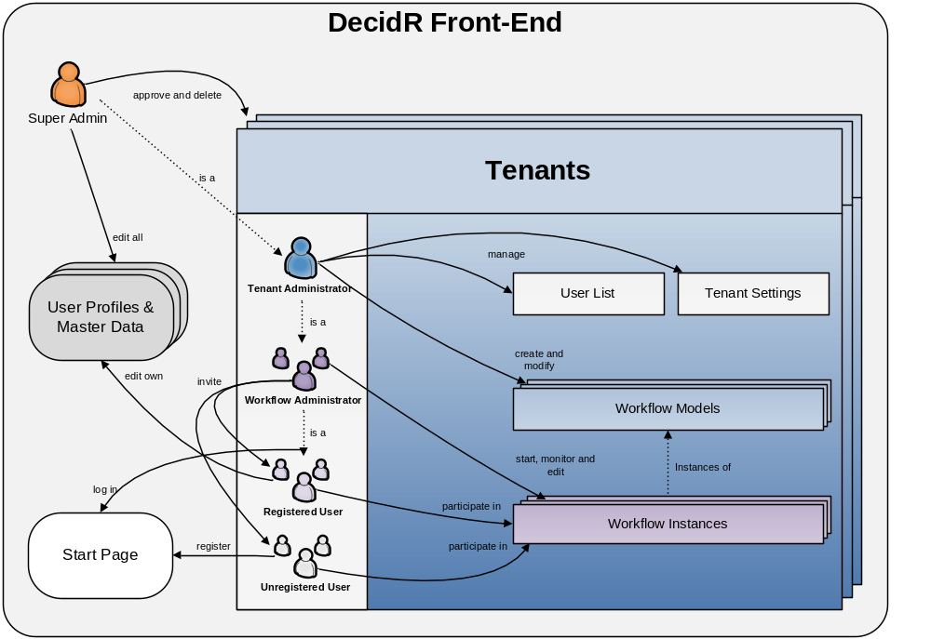
Figure 1: simplified conceptual view of the DecidR front-end
Since DecidR is a web application, users do not need a special client besides an up-to-date web browser to access its features. They must, however, register themselves on the DecidR web site in order to gain the full functionality. The following section summarizes the major functions that DecidR must let the user perform. Details are provided in section [Actors].

- System management
  - Approve or decline new tenants.
  - Delete existing tenants.
  - Edit user profiles & master data.
  - Edit system settings.
- Tenant administration
  - Create, modify and delete workflow models.
  - Share workflow models with other tenants by making them public.
  - Modify the tenant web page style such as a custom tenant logo.
  - Browse and manage a list of tenant members.
- Workflow administration
  - Send participation invitations to registered and unregistered users.
  - Start instances of the workflow models.
  - Monitor the status of running workflow instances.
  - Terminate running workflow instances.
- Workflow participation
  - Join existing tenants by invitation.
  - View your personal work list.
  - Complete tasks on your work list such as filling out a web form, uploading files, etc.
- Public start page
  - Log in with an existing user account.
  - Create a new user account with or without an invitation. Optionally create a new tenant or join an existing one when creating a new account.
  - Change your password.
- Personal start page
  - Edit your personal profile including address data, password, membership status etc.
  - Switch between different tenants.

User Classes and Characteristics
The project team anticipates very diverse user groups in terms of frequency of use, technical expertise, experience and educational level. Therefore, the user classes have been distinguished by the subset of used product functions. Note that the user classes are not disjoint. For example, a tenant administrator may himself take the role of workflow admin and workflow participant. There is some correlation with the use case actors found in section 5.1.

Super Administrator
- Responsible for approving new tenants, manages the database and is capable of repairing the system if an error occurs in one of its components.
- Familiar with the system and its implementation.
- Owns all rights and privileges.
- He is the sole administrator of the default tenant.

Typical example: an IAAS staff member who is involved in the project.

Tenant Administrator
- Responsible for modeling workflows and managing tenant settings.
- Has a basic understanding of workflow management, but not necessarily BPEL.
- Owns all rights within the tenant he administrates.
- Like any other user, he may participate in workflows.
- Must be registered on DecidR web site.

Typical examples: managers, teachers, project leaders.

Workflow Administrator
Workflow administrators are very similar to tenant administrators, except for their rights and responsibilities, which are limited to starting and managing workflow instances.

Workflow Participant
- Only deals with workflows by completing tasks on his personal work list(s).
- Doesn’t necessarily have any knowledge concerning workflow management.
- Doesn’t have any special rights or privileges that exceed participation in selected workflows and management of his personal user profile.
- May not even have registered on the DecidR web site.
- Uses his web browser and e-mail program competently, but doesn’t necessarily have any other technical or even computer science skills.

Typical examples: students, company employees.

Operating Environment
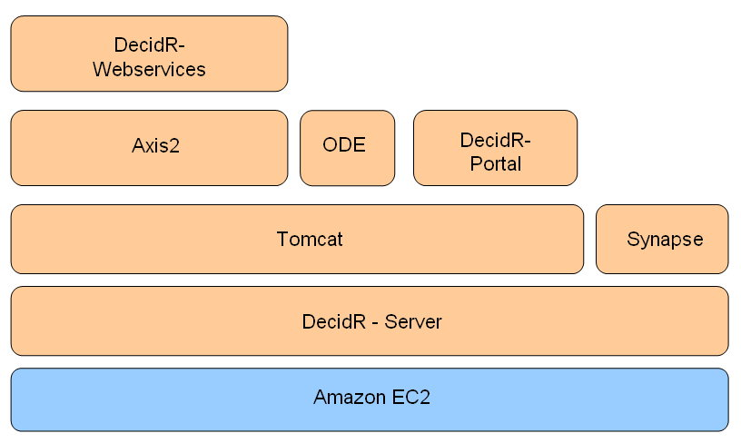
Figure 2: layers of software and infrastructure
DecidR runs on the Amazon EC2, which means it is possible to adjust the computing power within minutes. DecidR should be designed to run on every system on which Synapse and Tomcat can be deployed. The DecidR system consists of the DecidR portal and the DecidR web services, which are used as workflow tasks. Both components are deployed on the Tomcat server. Furthermore Apache Axis2 and Apache ODE are required to execute the workflow models. Synapse is used for web service discovery.
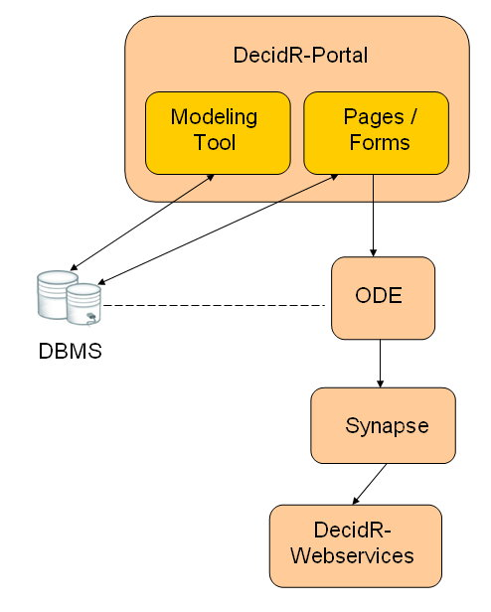
Figure 3: communication between system components
The DecidR portal component provides access to the DecidR system. It is the entry point for anyone who wishes to model and execute decision processes with DecidR. The portal is based on JavaServer Pages and includes the modeling tool and web forms. The modeling tool saves the created workflow models to the database. The web pages include the function to create instances of the workflow models and to execute them. The workflows are executed by the Apache ODE BPEL engine. The several tasks in the workflow are implemented using web services. These web services are accessed through the Synapse ESB. Furthermore the servlets and JavaServer Pages use the database for persistent data storage.

Design and Implementation Constraints
This section describes the issues that will limit the options available to the developers during the design and implementation phases.

Third Party Components & Libraries
All used third party components and libraries must be available under a license that is compatible with [licns].

Interfaces to other applications
Users should be able to invoke external web services in workflows by supplying a WSDL 1.1 file during the modeling stage. However, this is a low priority requirement. There are no interfaces to non-web service based applications.

Technologies & Standards
All DecidR subsystems except for the front-end (including the modeling tool) must be designed and implemented using web services. As WS-BPEL only supports WSDL 1.1[wsdl], the DecidR web services must be described using the 1.1 revision of the standard.
The front-end must be implemented using JavaServer Pages (JSP) and servlets [srvlt]. It will run in a Tomcat 5.5.x servlet container, which limits JSP to version 2.0 and servlets to version 2.4.

Frameworks & APIs

Java Persistence API (JPA)
The JPA does not constrain the database design since it can be used to create data models from existing database schemas.

Infrastructure
DecidR must be deployable in the Amazon EC2 as well as in traditional Linux or MS-Windows server environments. Therefore, the DecidR application must not rely on features, services or technologies that are exclusive to the Amazon EC2, such as the S3 storage service.
An important limitation comes from using MySQL as the persistent data backend: at the moment, the only database engine that supports transactions as well as foreign key consistency is InnoDB. However, creating full text indices is not supported by InnoDB, which must be considered during the design phase.

Tools
The client has not requested the use of specific software development tools.

Language Requirements
All documentation including source code comments must be written in English. Web services must be implemented using the Java language. The project team is free to use the latest Java runtime environment that is supported under the MS-Windows and Linux platforms.

Programming Standards
All code written by the DecidR project team should conform to the Java code conventions [codcv].

User Documentation

Installation Guide
The installation guide contains the necessary steps and prerequisites to deploy the DecidR application on the Amazon EC2 as well as traditional Linux and MS-Windows server environments. Additionally, it explains the configuration files and deployment descriptors that come with the DecidR server components.

Integrated Help
While it’s a very important goal to make the DecidR front-end user-friendly and intuitive, it must provide an integrated help system consisting of hierarchically structured HTML pages. There will be no separate user manual.

Extension Guide
The extension guide should help maintainers of the DecidR application with creating additional modules or services, extending the web front-end, etc.
The guide should contain several use cases that cover the most important extension tasks.

Assumptions and Dependencies
- The project team assumes (but does not know for a fact) that the requirements concerning the workflow modeling tool can be met using the Draw2D framework. The options provided by the Draw2D framework also determine the degree to which the look and feel of the workflow modeling tool may be customized.
- There is some dependency on third party software such as Tomcat, Synapse, Axis2, ODE, MySQL (and the InnoDB engine).
- The project team assumes that a correct mapping between relational database types and Java types is provided by the JPA.

User Interface

Overview
This section gives a brief overview of the DecidR user interface. The user interface will be explained in detail in the external document [uidoc]. The information in this section and the external document can deviate from each other. Due to the fact that this section should give just a first impression, it will not be updated and the information in the external document is valid in case of deviation.

The User Interface allows the user to interact with the DecidR System. It allegorizes the interface between the user and the application logic. It is accessible by Internet Explorer Vers.7 and Mozilla Firefox 3. The interface is optimized for a resolution of 1024x768 upwards.

Public Welcome Page
On the public welcome page the user has the opportunity to view information about DecidR, help pages, terms of service and impressum. Furthermore he is able to login, register and request a password reset of his user account.
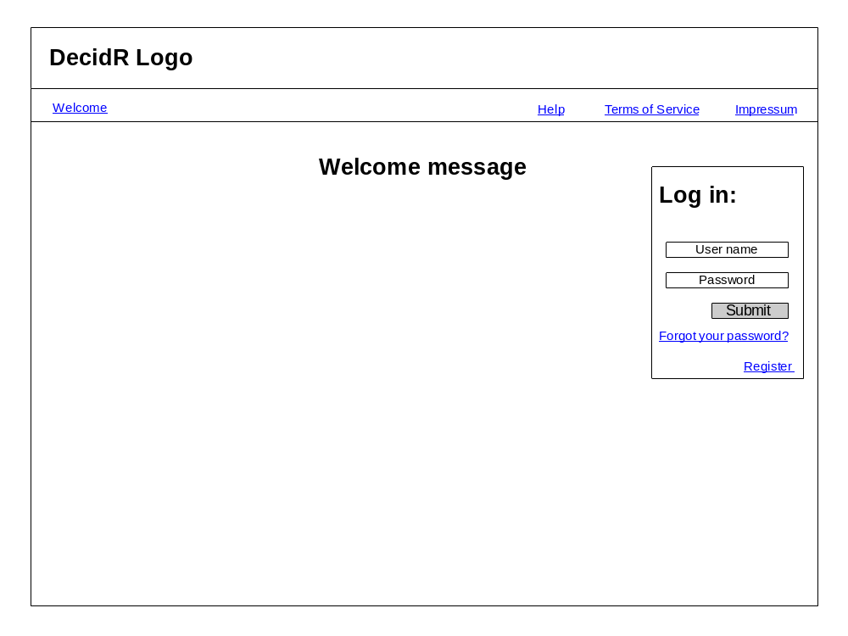
Figure 4: public welcome page

Logged in View
The following picture shows the general layout of the interface for logged in users:
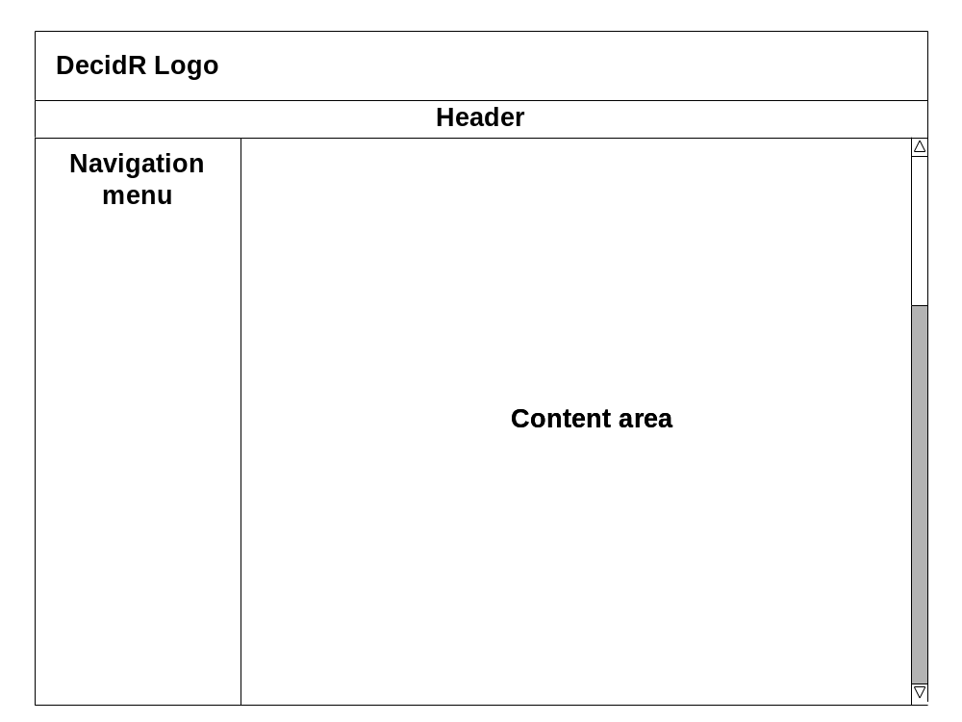
Figure 5: general layout for logged in users
In the logged in status the user has furthermore the opportunity to view help pages, terms of service and impressum. He also is able to logout.

On the left side, you can see the navigation bar. It has to be adjusted for each user role. Due to the fact that the “higher” users have also the rights of the lower ones, the items of a lower user are also shown for the higher one. A full navigation bar has the following entries:
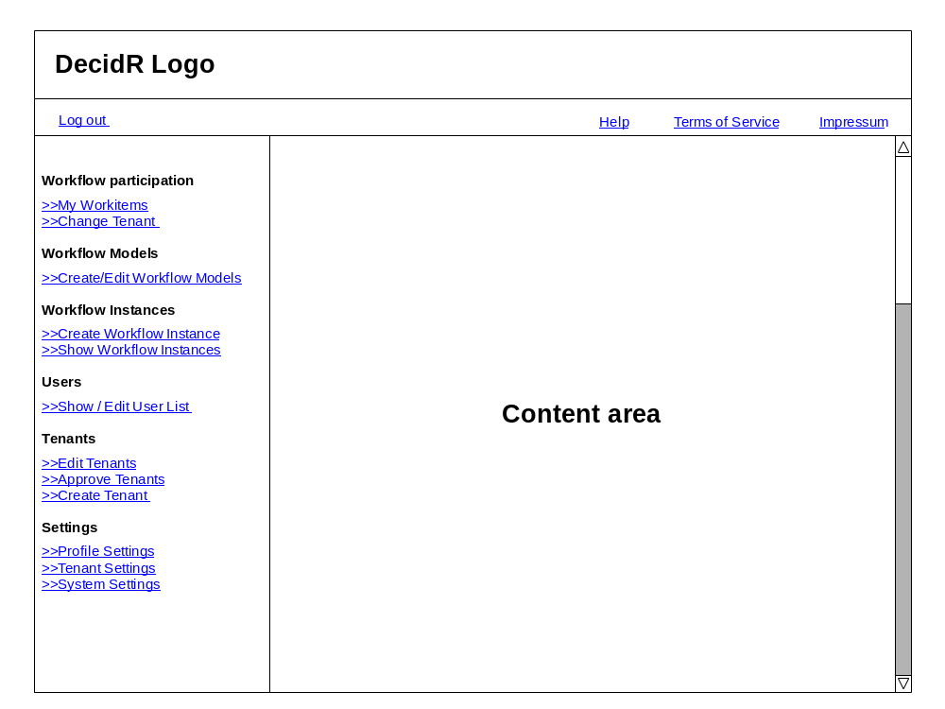
Figure 6: complete navigation menu
The entries for the different user roles are:

User:
- Workitems
- Profile Settings
- Change Tenant

Workflow-Admin:
- Create Workflow Instance
- Show Workflow Instances
- Show Userlist

Tenant Admin:
- Create/Edit Workflow Models
- Tenant Settings
- Edit Userlist

Super-Admin:
- Edit Tenants
- Approve Tenants
- System Settings

User Pages

Workitems
In the navigation bar, the number of new work items will be shown in brackets next to the entry “My Workitems”. The work item page shows a table with all user specific work items of the current tenant. Furthermore the user has the possibility to work on a work item or to mark a work item as done.
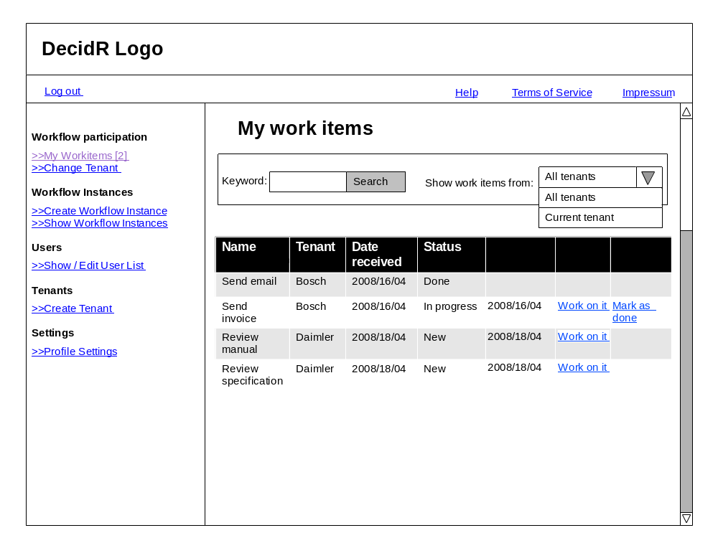
Figure 7: my workitems
The User also has the possibility to sort/filter the list and to show all work items, means also the work items of the other tenants he takes part.

Profile Settings
In this section the user can change his profile settings and set his status to inactive.
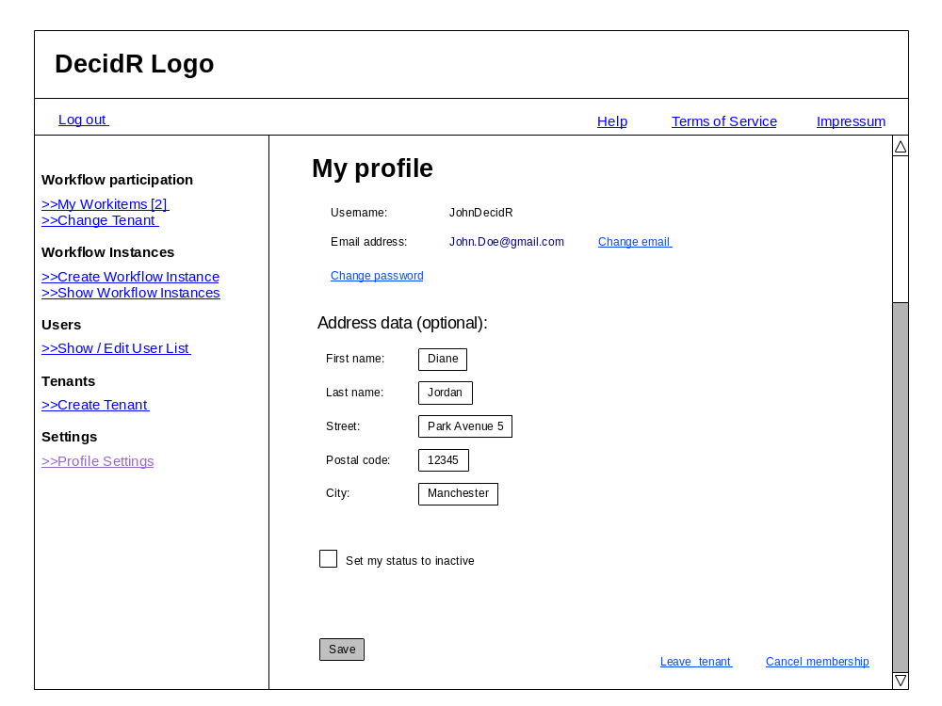
Figure 8: profile page

Change Tenant
In this section the user can switch between tenants. A List of all tenants the user is member of is shown. By clicking on a switch button next to a tenant name he can change to this tenant.
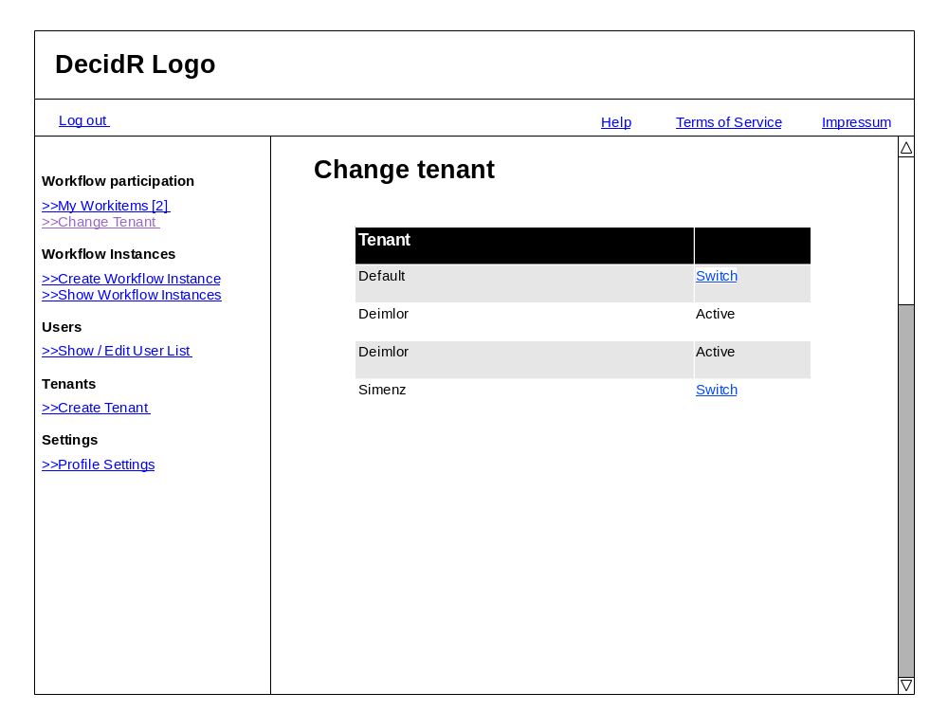
Figure 9: change tenant page

Workflow Admin Pages

Create Instance
On this page all workflow Models the workflow admin has access to are shown. He is able to create an instance of one of the models by clicking on the “create instance” button next to the model name. He is also able to filter the workflow models.
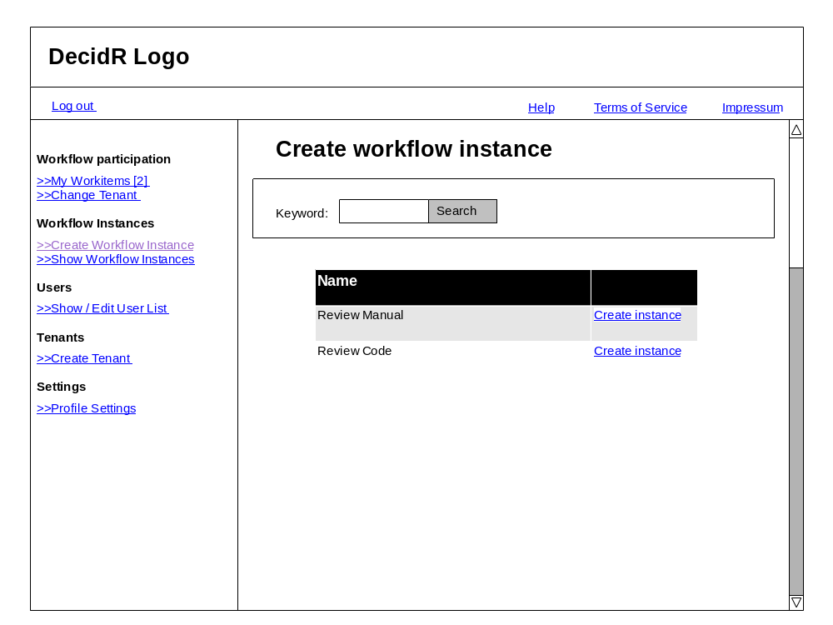
Figure 10: create workflow instance
After clicking on a “create instance” button, the user have to set the model specific variables and to assign users to the instance.

Show Workflow Instances
In this section the user can see all running instances of the current tenant and if required he can stop them.
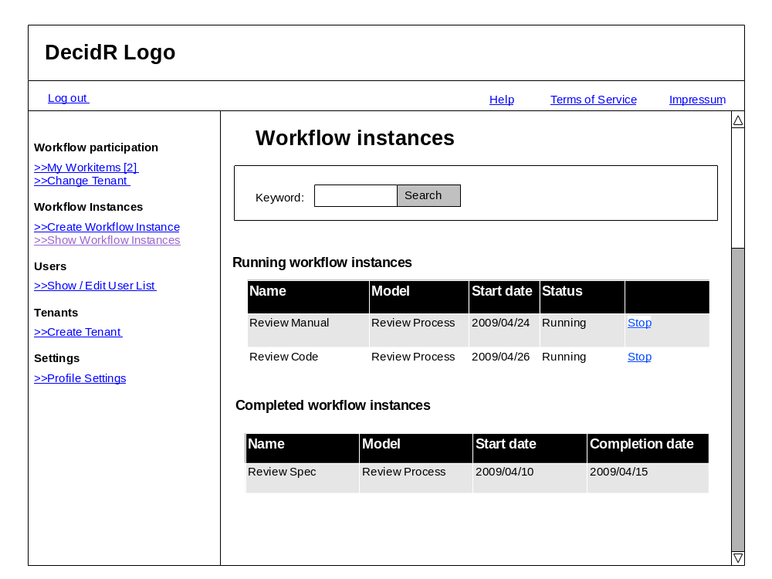
Figure 11: show workflow instances

Show Userlist
By using this item the workflow admin can view all users, which are a member of the tenant.
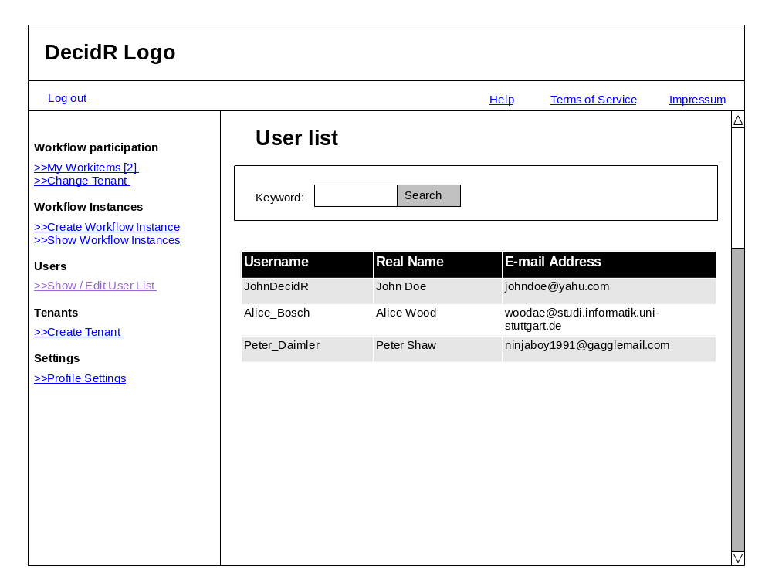
Figure 12: show userlist

Tenant Admin Pages

Create / Edit Workflow Models
Here the User can see a list of all public and tenant specific workflow models. The user is able to create a new workflow models and to edit, delete, publish or un-publish and to appoint the workflow administrators to tenant specific models.
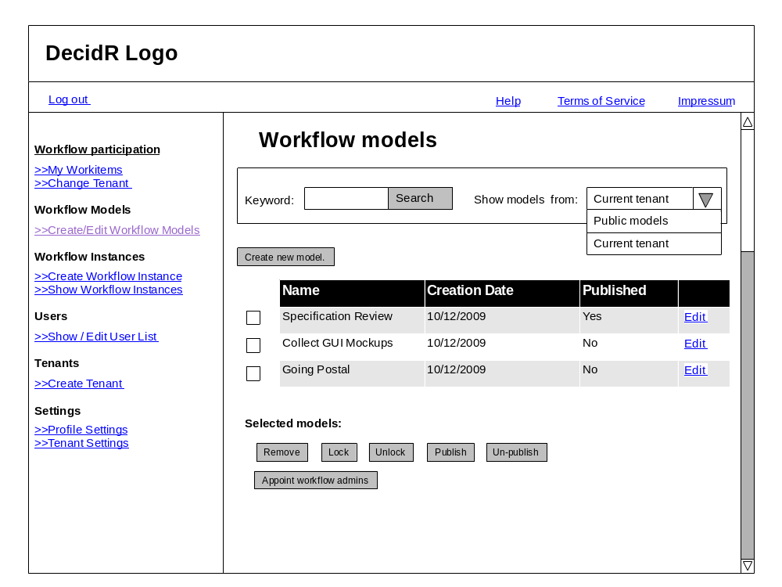
Figure 13: workflow model view (current tenant)
He can change the view to the public mode by using the combo box. In this view he is able to import one or more public models to his tenant.
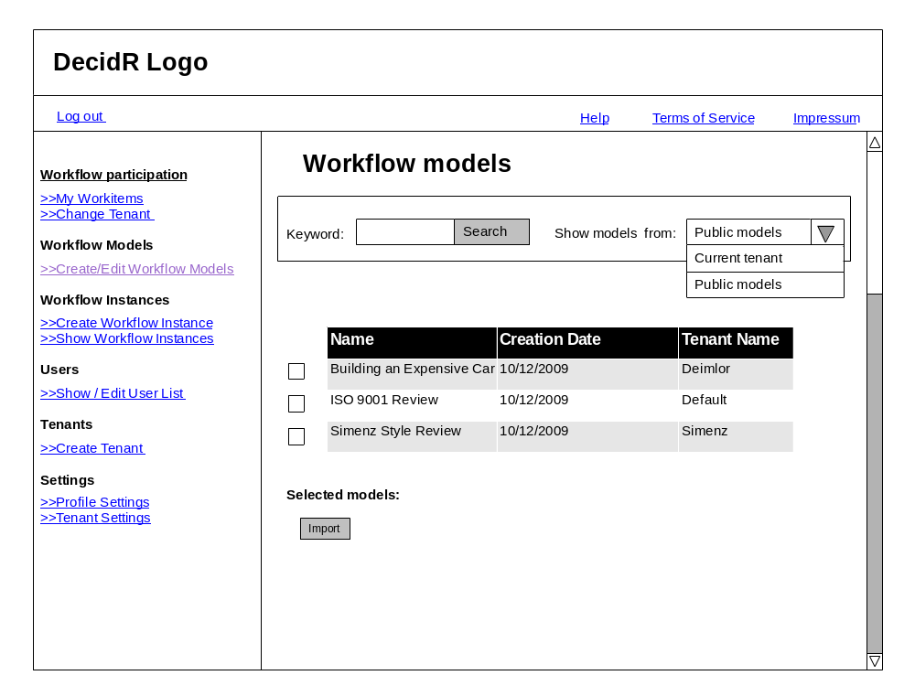
Figure 14: workflow model view (public models)
By pressing edit button in the “current tenant view”, the user is able to change the model and the model name.

Tenant settings
On this page the user can change the tenant specific data. He can set an information text, a logo and the tenant specific color scheme. Furthermore he can navigate to the advanced settings.
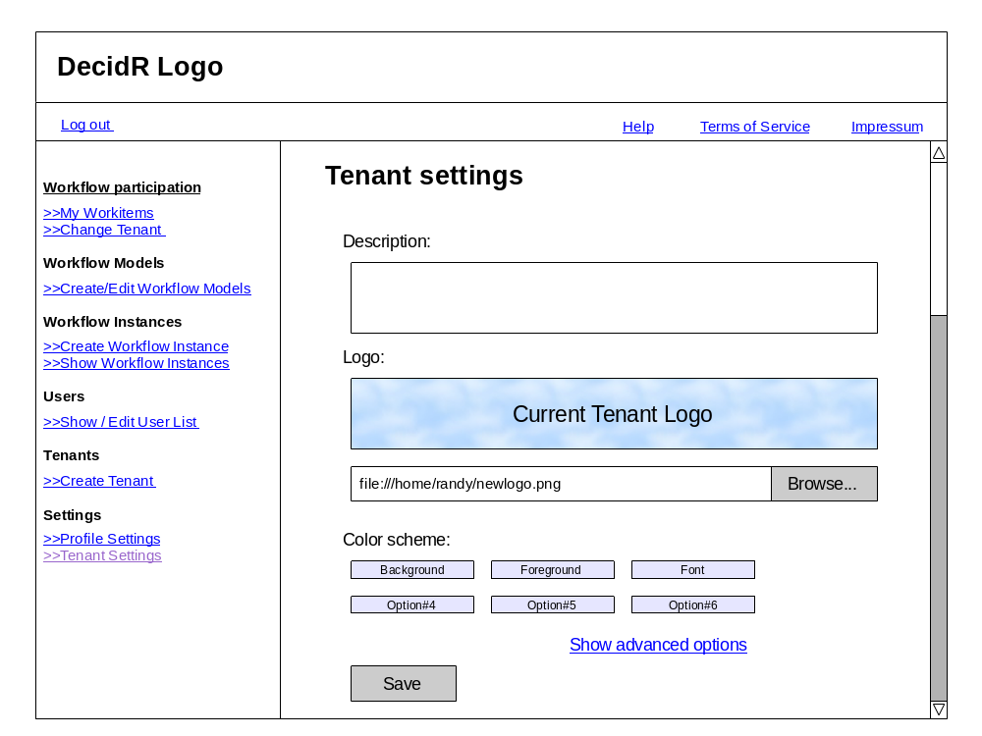
Figure 15: tenant settings (simple)
In the advanced setting he is abele to set the color scheme by using a css file.
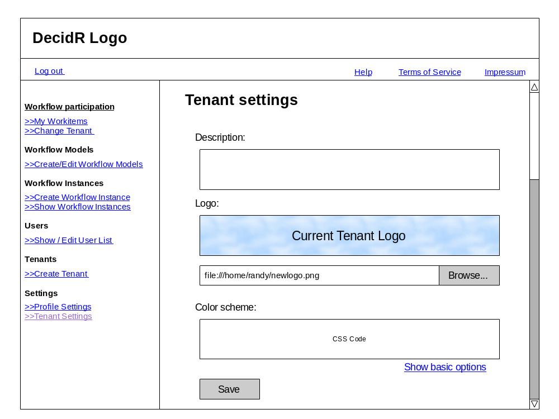
Figure 16: tenant settings (advanced)

Edit Userlist
On this page, the user can delete and invite users to the tenant. Furthermore he can change the user data. He also can filter the shown information.
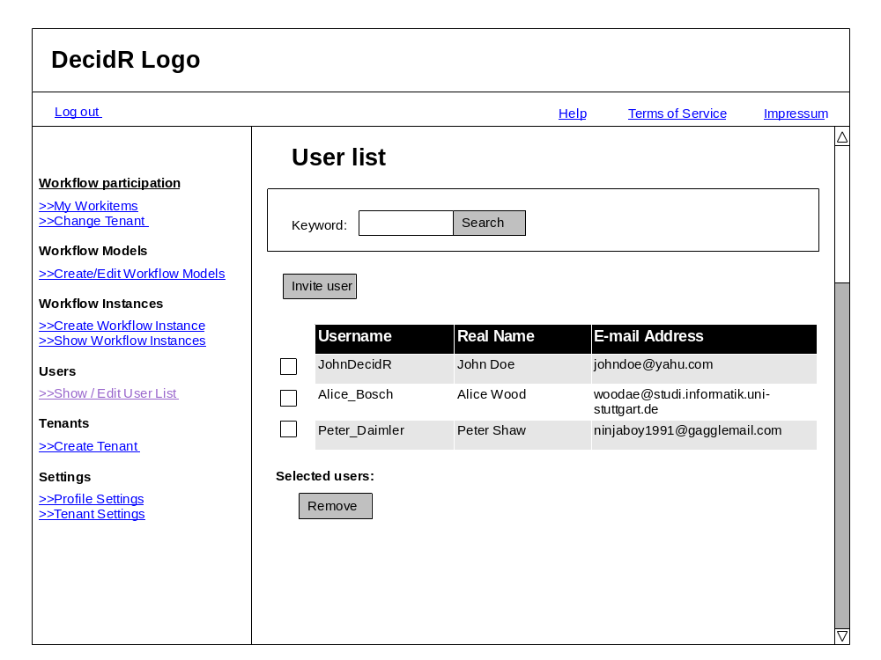
Figure 17: edit user list (tenant admin)

Super Admin Pages

Edit Tenants
On this page the super admin can list all tenants and delete them.
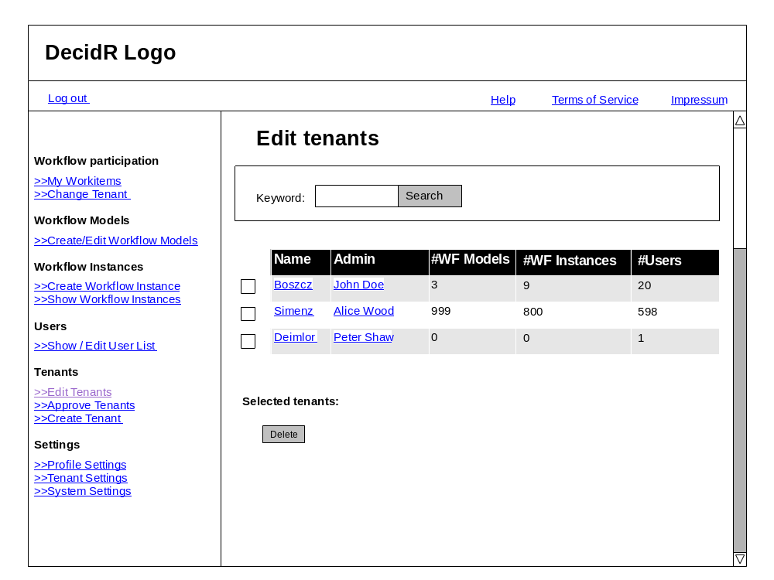
Figure 18: edit tenants

Approve Tenants
In this section the super admin can approve or decline tenant registrations.
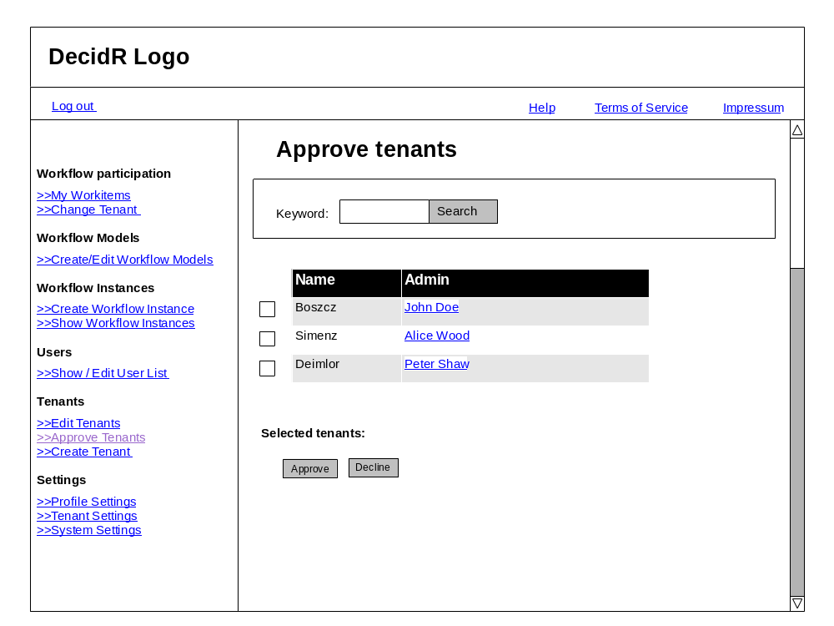
Figure 19: tenant approval

System Settings
In this section the super admin can change the log level and can choose whether tenants registrations should approved automatically or not.
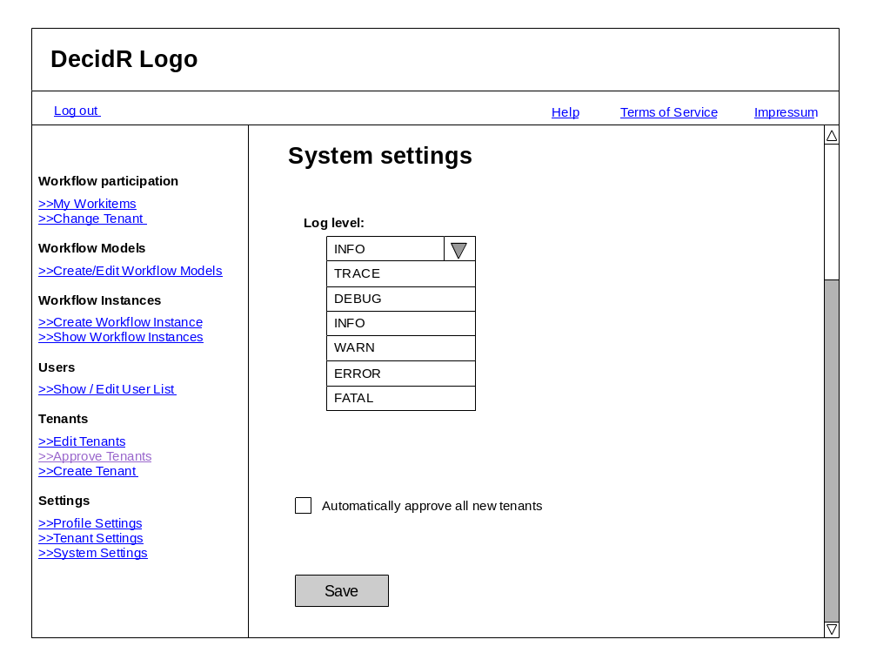
Figure 20 system settings

Show /Edit Users
On this page the super admin can show all users. He is able to delete, create and change user data tenant wide.
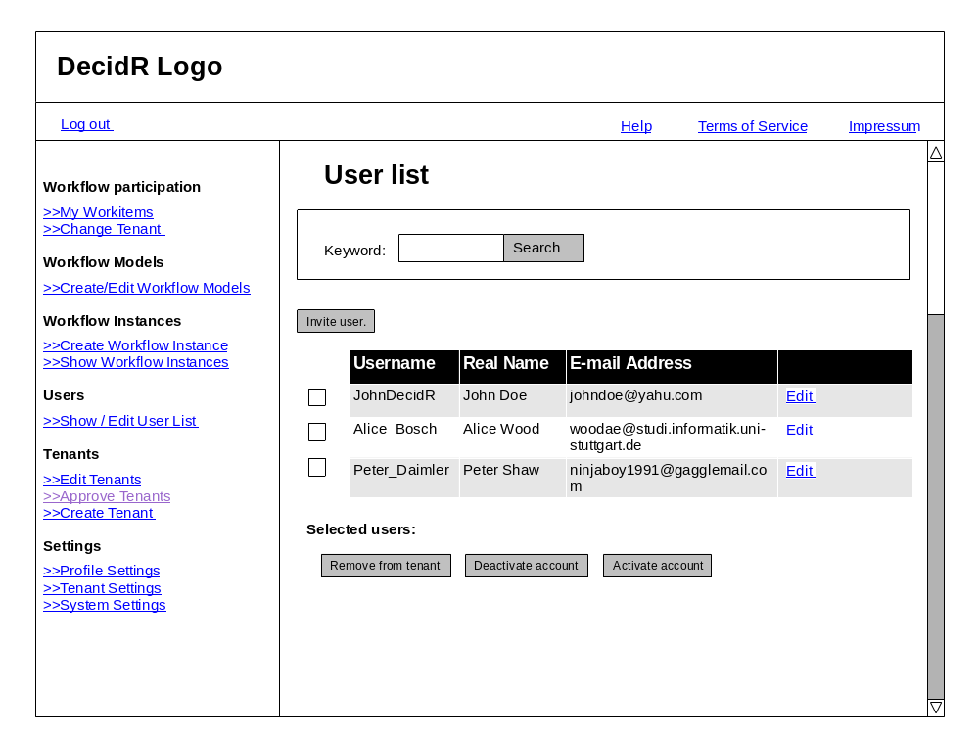
Figure 21 edit users (super admin)

Modeling Tool and Modeling Semantics
The purpose of this chapter is to describe the Modeling Tool of DecidR and the underlying semantics. The user can model workflows graphically with the Modeling Tool. The BPEL semantics of the graphical elements are described in this chapter.

Overview
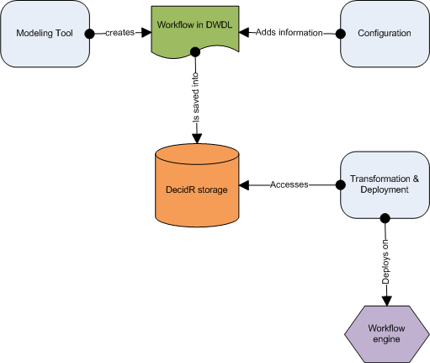
The tenant admin models a workflow with the modeling tool. The workflow is saved in an XML file. The XML Format of the file is the DecidR Workflow Definition Language (DWDL). The XML file serves two purposes: It is the source document for the transformation into a BPEL workflow and is the storage format for the graphical representation of the workflow. Whenever the tenant admin wants to load a workflow, the XML file is read. A transformation and deployment component is responsible for the conversion from DWDL to BPEL and for the deployment on to a workflow engine. The workflow admin can and in some cases has to configure the workflow by adding additional information. Whenever the workflow admin wants to start a workflow, meaning creating an instance of the workflow, the transformation and deployment component is activated.

The Modeling Tool
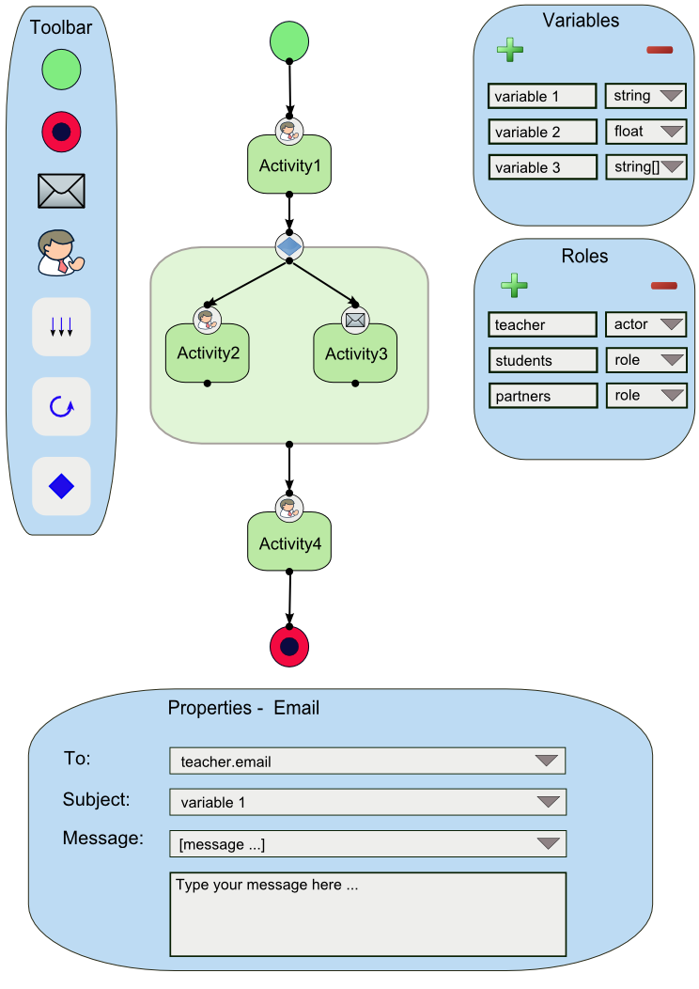

The Modeling Tool allows the tenant admin to design a workflow. Workflows are basically designed as a graph with nodes and edges. A node represents an activity or a container. Edges represent the control flow. The Modeling tool interface consists of a canvas, a toolbar, a variables list, a role list and a property window. The graphical elements of the workflow are placed on the canvas. The toolbar allows the tenant admin to choose from activities and containers and place them on the canvas. In the variables list, the tenant admin can add, modify or delete variables which serve either as input or as output variables for the activities. With the role list the tenant admin can define roles. The property window displays the preferences of each activity, for example input and output variables.

Toolbar Elements
- Workflow related elements
  - Start activity
  - End activity
  - Email Web Service activity
  - Human Task Web Service activity
  - Flow container
  - If container
  - For Each container
- Editor related elements
  - Undo: The user can undo his last action
  - Redo: The user can redo a revoked action
  - Clear: Clear the workflow canvas to the default
  - Delete: Deletes a workflow element
  - Save: Saves the workflow

Variables List
The Variables List contains a list of variables. The tenant admin can add, modify or delete a variable from the list. Each entry of the list contains the unique variable name, the variable type and the variable value. Every variable is globally available, that means every variable on that list can be assigned to every activity as either an input variable or an output variable. The assignment is done in the property window of each activity. A variable can have one of the following types:

- Simple types
  - Integer
  - Float
  - String
  - Boolean
  - Date (consisting of year, month and day)
- Complex types
  - File reference
  - List of any simple type or reference

Role list
The role list contains a list of roles. The tenant admin can add, modify or delete an entry from the list. Each entry of the list contains the unique role name and the role. There can be two types, either a role (a set of persons) or an actor (exactly one person). Example: In a university lecture context, a role would be “student” (a set of persons); an actor would be “professor” (exactly one person). The “For Each container” can iterate over a role, but not over an actor. The “Human Task activity” accepts as input variable user an actor, but not a role.

Property Window
Whenever a tenant admin clicks on an activity or container, a property window is displayed. In this property window he can configure the activity or container. For every input and output variable of an activity, the tenant admin can assign a variable from the variables list through a pull down menu. Alternatively, instead of assigning a variable, he can choose the “define” entry of the pull down menu. A text field or area is the displayed, where he can enter the value of the input variables.

Activities
The following section describes the activities of which the workflows are composed of. Each activity has a short description of its functionality. The “Properties” section specifies the contents of the property window of an activity.

Start activity
Every workflow has to start with a start activity. It represents the beginning of the control flow. Within a start activity, a tenant admin can determine the configuration variables of the workflow. The configuration variables are normal variables which are created through the Variables List and are assigned as configuration variables in the property window of the start activity. All configuration variables together resemble the start configuration of the workflow. The start configuration has to be initialized by the workflow admin. The concept of configuration variables allows the tenant admin to model workflows independently of a workflow admin specific scenario. Having to initialize the start configuration, the workflow admin has the possibility to custom tailor each workflow instance to his wishes.

End activity
Every workflow has to end with an end activity. If the control flow a workflow instance reaches this activity, the workflow instance counts as successfully executed.

Properties:
- Fault Handler: The tenant admin has to define a role or an actor to which an email (with a customizable message) will be sent if the execution of a workflow instance has failed for any reason.
- Notify of Success: The tenant admin can check whether an email should to sent out to a role or actor if the control flow has successfully reached the end activity.

Email Web Service activity
The Email Web Service sends emails to a given address with a specific subject and message.
Properties:
- Input variables
  - To (string or actor): Has to contain the recipient’s Email address
  - CC (string or actor): Can contain the recipient of a carbon copy
  - BCC (string or actor): Can contain the recipient of a blind carbon copy
  - Subject (string): Has to contain the subject of the email
  - Message (string): Can contain the message body of the email
  - Attachment (list of file references): Can contain a reference to the file that will be sent out as an attachment to the email
- Output variables
  - Sent (Boolean): Whether the email was sent successfully

Human Task Web Service activity
The Human Task Web Service creates work items for a specific participant of a workflow instance. The work item is displayed in the user’s work item list. A work item consist basically of a text part, an input form part and optionally a file upload and provide part. The text part describes what the user’s task is and what he has to do. The input form part contains one or more input fields, where the user can enter his result of the task he has been given.

Properties:
- Input variables
  - User (actor): Has to contain the username of the user who the task is designed for
  - Task description (list of strings): Has to contain the description of the task
  - File (list of file references): Can contain a file reference to a file
- Output variables
  - Input field (list of string, date, integer, Boolean or float): Can contain the values of the input fields form the input form part
  - File (list of file references): Can contain the file reference to a file the user has uploaded
- Options
  - Notify user per email: The tenant admin can decide whether an email should be sent out notifying the user that a new work item was assigned to him

Containers

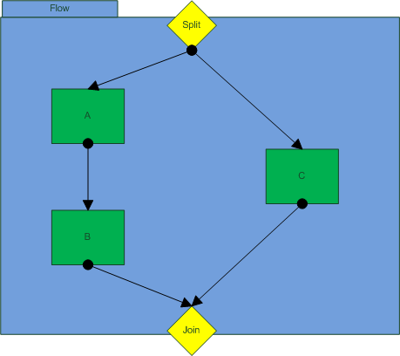
Flow container
If the tenant admin wants two or more activities or sequences of activities to be executed simultaneously, he has to place them in a flow container. A Flow container consists of a split point, a join point and the container area. The Split point is the target for an incoming edge outside the flow container. The split point is also the source of outgoing edges inside the container which point to activities that are executed simultaneously. The join point is the target for incoming edges from inside the flow container, that means every activity or sequence activity inside the flow container ends at the join point. The join point is the source of the outgoing edge outside the flow container. The join point is a gateway with an AND-condition. Every activity or sequence of activity has to end successfully to continue the control flow after the flow container.

If container
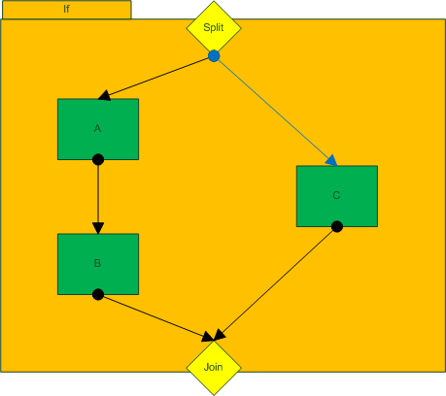
If the tenant admin has two or more activities or sequences of activities and he wants only one of them to be executed dependent on whether certain conditions are true, he has to place them in an If container. An If-container consists of a split point, a join point and the container area. The Split point is the target for an incoming edge outside the If container. The split point is also the source of outgoing edges inside the container which point to activities. In order to secure the execution of at least one sequence of activities even if no condition statement is true, there is one special outgoing edge from the split point: It is specifically colored and points to that sequence of activities which is executed if no condition is true. The join point is the target for incoming edges from inside the If container, that means every activity or sequence activity inside the If container ends at the join point. The join point is the source of the outgoing edge outside the If container. The join point is a gateway with an XOR-condition. Only one activity or sequence of activity has to end successfully to continue the control flow after the If container.

Properties:
For each outgoing edge, the tenant admin must define a transition condition. A condition statement is a Boolean expression where relational operators are applied to variables or roles. A condition statement looks like the following:
<Variable, List or Role> <Relational operator> <Value>

The variable, list or role can be selected by a pull down menu. According to the type of variable or list, the set of allowed relational operators are presented in an additional pull down menu. The value to which the variable is compared to has to be entered in a text field. The following relational operators are allowed for each type of variable:
- String
  - Equal to (“==”)
  - Contains (“?=”)
- Integer
  - Equal to (“==”)
  - Smaller than (“<”)
  - Smaller than or equal to (“<=”)
  - Greater than (“>”)
  - Greater than or equal to (“>=”)
- Float
  - Smaller than (“<”)
  - Greater than (“>”)
  - Equal to (“==”)
- Date
  - Equal to (“==”)
  - Before (“<”)
  - After (“>”)
- Boolean
  - Equal (“==”)
- Role/List
  - The same relational operators as listed under “integer” can be applied. But here, the comparison is in regard to the cardinality of the list or set respectively.

For each container
The For each container allows a tenant admin to iterate over a range of integer values, lists or roles. The activity or sequence of activity in the container is executed every iteration. Within a For each container, a loop variable is available. The type of the loop variable corresponds to the iteration object. The loop variable is a local variable, i.e. it can only be chosen by the activities in the container as an input or output variable.

Properties:
- Iteration object: The tenant can choose to iterate over a range of integer values, lists or roles
- Exit condition: The tenant admin can choose between an AND- or XOR-Exit. An AND-Exit means that every activity has to end successfully in order for the control flow to continue after the For each container. A XOR-Exit means that only one activity has to end successfully. If a sequence of activities has been defined in the container exactly one whole sequence has to complete successfully on order to meet the XOR-condition.

The DecidR Workflow Definition Language (DWDL)
The DecidR Workflow Definition Language (DWDL) is an XML-based language. It has two purposes: The first purpose is to serve as a data format to store the workflow models and configurations, i.e. it contains all semantic and graphical information that is necessary to load a model into the modeling tool. The second purpose is to server as source format for the transformation into a BPEL workflow. In order to minimize the complexity of a transformation to BPEL, the DWDL was designed with the goal to be BPEL-near, i.e. many elements of DWDL are merely a reduction of the according BPEL elements. In this section, the XML scheme of the previous activities and container will be discussed.
Note: The graphical information is not part of this specification because it is considered a design aspect of the modeling tool

Header
This is the basic header which characterizes every DWDL-Document.
<?xml version="1.0"?>

<xsd:schema targetNamespace="http://decidr.org/schema/workflow"
xmlns="http://decidr.org/schema/workflow"
xmlns:xsd="http://www.w3.org/2001/XMLSchema"
elementFormDefault="qualified">

Root element
This is the root element of every workflow. The basic elements of a workflow element in DWDL are nodes, arcs and variables. The nodes and arcs represent the vertices and edges of a workflow graph and model the control flow. The variables allow modeling the data flow through the workflow.
<xsd:element name="workflow" type="tWorkflow">
<xsd:annotation>
</xsd:annotation>
</xsd:element>

<xsd:complexType name="tWorkfow">
<xsd:sequence>
<xsd:element ref="documentation" minOccurs="0" />
<xsd:element ref="variables" minOccurs="0" />
<xsd:element ref="faultHandler" minOccurs="0" />
<xsd:element ref="nodes" minOccurs="0" />
<xsd:element ref="arcs" minOccurs="0" />
</xsd:sequence>
<xsd:attribute name="name" type="xsd:NCName" use="required" />
<xsd:attribute name="targetNamespace" type="xsd:anyURI" use="required" />
</xsd:complexType>

Inline documentation
The DWDL XML scheme allows inline documentation.
<xsd:element name="documentation" type="tDocumentation" />

<xsd:complexType name="tDocumentation" mixed="true">
<xsd:sequence>
<xsd:any processContents="lax" minOccurs="0" maxOccurs="unbounded" />
</xsd:sequence>
<xsd:attribute name="source" type="xsd:anyURI" />
<xsd:attribute ref="xml:lang" />
</xsd:complexType>

Variables list
<xsd:element name="variables" type="tVariables" />

<xsd:complexType name="tVariables">
<xsd:sequence>
<xsd:element ref="variable" minOccurs="1" maxOccurs="unbounded"/>
</xsd:sequence>
</xsd:complexType>

<xsd:element name="variable" type="tVariable" />

<xsd:complexType name="tVariable">
<xsd:attribute name="name" type="WorkflowVariableName" use="required" />
<xsd:attribute name="type" type="xsd:QName" use="optional" />
<xsd:attribute name="element" type="xsd:QName" use="optional" />
</xsd:complexType>

<xsd:simpleType name="WorkflowVariableName">
<xsd:restriction base="xsd:NCName">
<xsd:pattern value="[^\.]+" />
</xsd:restriction>
</xsd:simpleType>

Fault Handler
<xsd:element name="faultHandler" type="tFaultHandler"/>

<xsd:complexType name="tFaultHandler">
<xsd:sequence>
<xsd:element name="message" type="xsd:string" minOccurs="1" maxOccurs="1" />
<xsd:element ref="notify" minOccurs="1" />
</xsd:sequence>
</xsd:complexType>

<xsd:element name="notify" type="tNotify">

<xsd:complexType name="tNotify">
<xsd:sequence>
<xsd:element name="name" type="xsd:string" />
<xsd:element name="email" type="xsd:string" />
<xsd:sequence>
</xsd:complexType>

Nodes
Nodes are activities and containers. Although there is one node for every container, the activities are to be composed of Assign, Invoke, Receive and Reply nodes. Each of these nodes has a BPEL counterpart. Every node has an input and an output port which are the targets resp. sources of the links of the control flow.
<xsd:element name="nodes" type="tNodes" />

<xsd:complexType name="tNodes">
<xsd:sequence>
<xsd:group ref="nodeTypes" minOccurs="1" maxOccurs="unbounded"/>
</xsd:sequence>
</xsd:complexType>

<xsd:group name="nodeTypes">
<xsd:choice>
<xsd:element ref="assignNode"/>
<xsd:element ref="flowNode"/>
<xsd:element ref="forEachNode"/>
<xsd:element ref="ifNode"/>
<xsd:element ref="invokeNode"/>
<xsd:element ref="receiveNode"/>
<xsd:element ref="replyNode"/>
</xsd:choice>
</xsd:group>

<xsd:element name="simpleNode" type="tSimpleNode"/>

<xsd:complexType name="tSimpleNode">
<xsd:sequence>
<xsd:element ref="ports" minOccurs="0" />
</xsd:sequence>
<xsd:attribute name="id" type="xsd:ID" use="required" />
<xsd:attribute name="name" type="xsd:NCName" use="optional" />
</xsd:complexType>

<xsd:element name="ports" type="tPorts" />

<xsd:complexType name="tPorts">
<xsd:sequence>
<xsd:group ref="portTypes" maxOccurs="1"/>
</xsd:sequence>
</xsd:complexType>

<xsd:group name="portTypes">
<xsd:choice>
<xsd:element ref="inputPort" />
<xsd:element ref="outputPort" />
</xsd:choice>
</xsd:group>

<xsd:element name="simpePort" type="tsimplePort">

<xsd:complexType name="tsimplePort">
<xsd:sequence>
<xsd:element ref="arcs" maxOccurs="1" />
</xsd:sequence>
<xsd:attribute name="name" type="xsd:NCName" use="optional" />
</xsd:complexType>

Arcs
Arcs represent the links of the control flow (the representation of edges of a workflow graph). The BPEL counterparts are links. Each arc has exactly one node as a source and a different node as target.
<xsd:element name="arcs" type="tArcs" />

<xsd:complexType name="tArcs">
<xsd:sequence>
<xsd:element name="arc" type="tArc" />
</xsd:sequence>
</xsd:complexType>

<xsd:complexType name="tArc">
<xsd:attribute name="id" type="xsd:ID" use="required"/>
<xsd:attribute name="source" type="xsd:IDREF" use="required" />
<xsd:attribute name="target" type="xsd:IDREF" use="required" />
</xsd:complexType>

</xsd:schema>

Introduction to System Features

Actors
The system roles are designed in hierarchical structure. A higher user can perform the operations which a lower one can perform and additional ones.

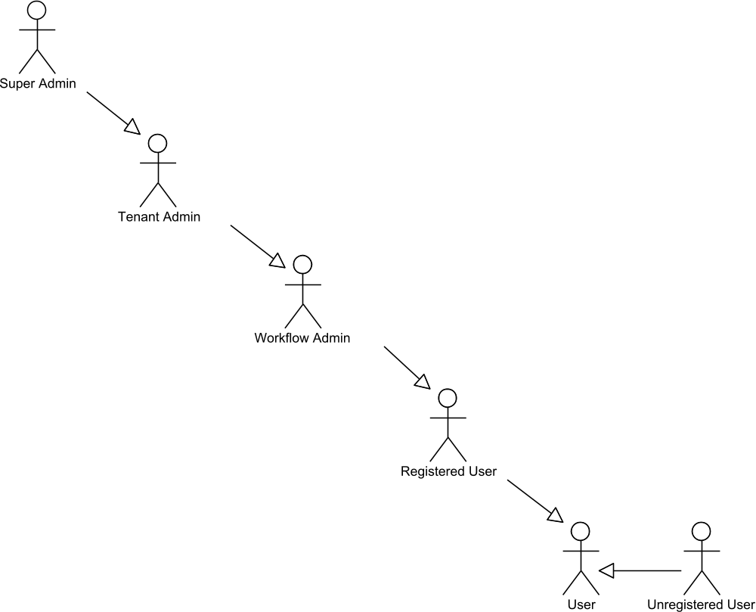
Figure 21 user overview

User
The user is the basic class on which all actors are based on. Every person who interacts with the DecidR system is called user.

Unregistered User
The unregistered user does not have a DecidR account. He is able to see the public information on the public part of the DecidR page. He can also take part in workflows, if he was invited by a workflow admin before.

Registered User
A registered user has performed the DecidR registration and owns a DecidR user account.
He is able to take part on workflows and can change his profile data.

Workflow Admin
The workflow administrator is a registered user, who has the rights to administrate one or more workflows. He is able to invite new users to a tenant.

Tenant Admin
The tenant admin is a workflow admin who has the additional rights to create and modify workflow models. He can also change the tenant settings.

Super Admin
The super admin is the head of the DecidR system. He has all rights in all tenants. He can access to all objects. Furthermore he can change the system settings.

Error Handling
In the following use cases in section system features only predictable errors are handled. All error messages will contain useful information for the user and will not just include bootless error codes.

Concurrency
In the following use cases in section system features there is no error handling for concurrent use of data. There will be following problems which could occur:
- A user wants to access to a file which does not longer exists.
System reaction: An error message will be shown.
- Two users change the content of and file and save it “parallel”.
System reaction: There don’t exist parallel save operations. The operations will be
performed in order and the last saved data is valid.
- User A is shown some data which will be chanced by another user B. User A performs an operation with the old data.
System reaction: The operation will be performed with the old data.

Access Control
In the following use cases in section system features there will be no information about the access rights to different objects. The user will only be shown the objects he has the right to access for. For security the system will check before accessing an object if the user has the rights to access. This guarantees that no user can access files he shouldn’t access by using other communication ways besides using the DecidR pages.

Priorities
Property | Description
Must-have | Must-have features are essential for the DecidR-System. These features will be implemented first and are part of the first iteration. The DecidR team assures that these features are completely implemented by the end of the project.
Desirable | The DecidR team aims to implement these features until the end of the DecidR project, but does not assure that these features will be implemented.
Nice-to-have | The DecidR team will implement these features, if there is enough time left after implementing and testing everything else.

Automated System Maintenance
The system triggers a system maintenance task every 24 hours, which checks whether objects like invitations and completed workflow instances are still valid or not. If they aren’t valid the task will delete them.

System Features

Info Pages
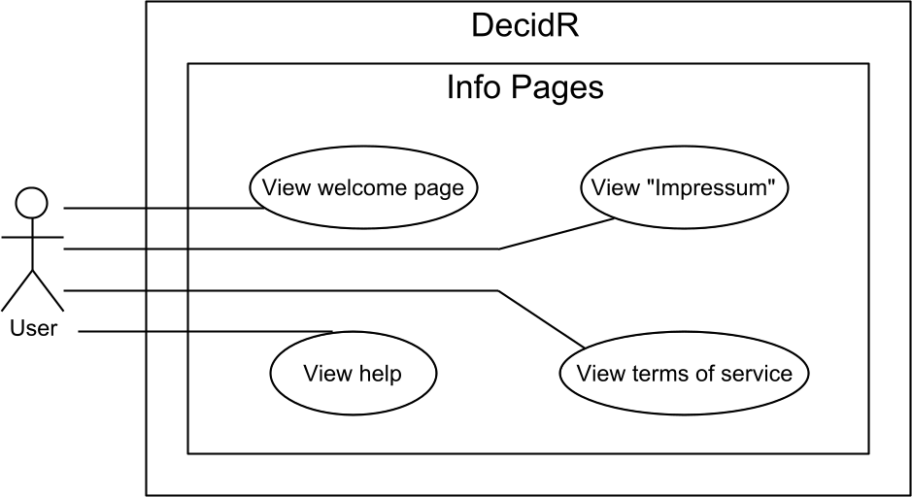
Figure 22 use case overview “info pages”

View “Impressum"
Priority | Must-have
Reference | Figure 4: public welcome page  Figure 6: complete navigation menu
Goal | The user wants to see the impressum.
Precondition | The user has opened any site of the DecidR web page.
Basic flow | - The user clicks on the „Impressum” link at the header.  - The system shows the impressum page.
Postcondition | Impressum page is shown.

View terms of service
Priority | Must-have
Reference | Figure 4: public welcome page  Figure 6: complete navigation menu
Goal | The user wants to see the terms of service.
Precondition | The user has opened any site of the DecidR web page.
Basic flow | - The user clicks on the „terms of service” link at the header.  - The system shows the terms of service page.
Postcondition | Terms of service page is shown.

View help
Priority | Must-have
Reference | Figure 4: public welcome page  Figure 6: complete navigation menu
Goal | The user wants to see the help pages.
Precondition | The user has opened any site of the DecidR web page.
Basic flow | - The user clicks on the „ help” link at the header.  - The system shows the help pages.
Postcondition | Help pages is shown.

View welcome page
Priority | Must-have
Reference | Figure 4: public welcome page
Goal | The user wants to see the welcome page.
Precondition | The user has opened the DecidR main page in his web browser.
Basic flow | - The user clicks on the „ welcome” link at the header.  - The system shows the welcome page.
Postcondition | Welcome page is shown.

Account Management
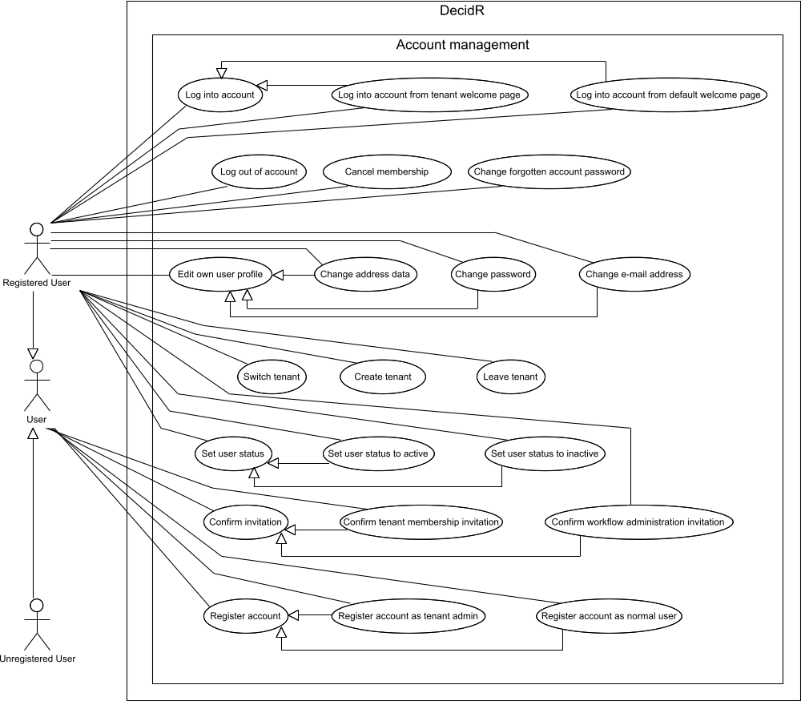
Figure 23 use case overview “account management”

Register account as tenant-admin
Priority | Must-have
Reference | Figure 4: public welcome page
Goal | The user wants to register as a new tenant admin and wants to create the corresponding tenant.
Precondition | The user has opened the DecidR main page in his web browser. The user is not logged in.
Basic flow | - The user follows the registration link.  - The system shows a page, where can choose between normal registration and tenant registration.  - The user chooses tenant registration.  - The system shows the registration page.  - The user enters his email address and name, accepts the terms of use and enters maybe and additional address data. Finally he presses the next button.  - The system checks if use of terms are accepted – result: yes  - The system checks if email address is already in use – result: email isn’t in use.  - The user enters the tenant information and presses finish.  - The system checks if the tenant name is already in use – result: isn’t in use  - The system creates the user account, sends a notification mail to the assigned email address and sets the account as “inactive”  - The system creates the tenant.  - Account gets accepted by the super admin (see Approve new tenants) or gets accepted automatically by the system due to the super admin settings.  - The System sets user account status to active.  - The system sends a notification email to the assigned email address.
Postcondition | Tenant and user account are created and set to active.
Alternative flow (1) | 5a. The terms of use haven’t accepted by the user.  6a. The system shows an error message “terms of use not  accepted”.
Alternative flow (2) | 7a. The system checks if the email address is already in use –  result: Email is already in use.  8a. The system shows an error message “email address already in  use”.
Alternative flow (3) | 9a. The system checks if the tenant name is already in use –  result: name is already in use  10a. The system shows an error message “tenant name already in  use”.
Alternative flow (4) | 12a. Account isn’t accepted by the super admin  13a. The system send an email to the assigned email address  that informs the user that the account was not accepted by  the super admin  14a. The system deletes the corresponding user account and the  corresponding tenant.
Alternative postcondition | - Tenant and user account are not created.  - The user may continue with previous step.

Register account as normal user
Priority | Must-have
Reference
Goal | The user wants to register at the DecidR web site.
Precondition | The user has opened the DecidR main page in his web browser. The user is not logged in.
Basic flow | - The user follows the registration link.  - The system shows a page, where can choose between normal registration and tenant registration.  - The user chooses normal registration.  - The system shows the registration page.  - The user enters email address and name, accepts the terms of use and enters maybe optional information. Finally he presses the next button.  - The system checks if use of terms are accepted – result: yes  - The system checks if email address is already in use – result: Email isn’t in use.  - The system save the user account, send registration mail to the assigned email address and set the account as “inactive”  - User confirms registration by clicking on the activation link sent by email.  - The System set account as “active”.
Postcondition | The user account is created and activated.
Alternative flow (1) | 5a. The terms of use hasn’t accepted by the user.  6a. The system shows an error message “terms of use not  accepted”.
Alternative flow (2) | 7a. The system checks if the email address is already in use – result: Email is already in use.  8a. The system shows an error message “email address already in  use”.
Alternative postcondition | - The user account isn’t created.  - The user can continue with step 3.

Log into account from default welcome page
Priority | Must-have
Reference | Figure 4: public welcome page
Goal | The user wants to login to DecidR.
Precondition | The user has opened the DecidR main page in his web browser. The user is logged out.
Basic flow | - The user enters his username and password into the appropriate fields.  - The user clicks on the Login-Button or presses the return key.  - System accepts the login data.  - The system displays the user’s work item page.
Postcondition | The user is logged in and can view the start page. The page style is the default theme. The work item list shows work items from all tenants.
Alternative flow (1) | 3a. The system rejects the login data.  4a. The system displays an error message stating that  username or password is incorrect.
Alternative postcondition (1) | - The user is not logged in and the error message is shown.
Alternative flow (2) | 3a. The system rejects login data for the 10th time.  4a. The system displays an error message stating that  username or password is incorrect. A notification E-  Mail is sent to the corresponding admin.
Alternative postcondition (2) | - The user is not logged in and the error message is shown.  - Super admin received notification mail.

Log into account from tenant welcome page
Priority | Must-have
Reference | None.
Goal | The user wants to login to DecidR.
Precondition | The user has opened a tenant specific login page (www.decidr.com/<tenant-name>) The user is logged out.
Basic flow | - The user enters his username and password into the appropriate fields.  - The user clicks on the Login-Button or presses the return key.  - Username and password are correct.  - The system displays the users’ work item page.
Postcondition | The user is logged in and can view the start page. The page style is the tenant specific theme. The work item list shows work items according to the tenant.
Alternative flow (1) | 3a. The system rejects login data.  4a. The system displays an error message stating that  username or password is incorrect.
Alternative flow (2) | 3a. The system rejects login data for the 10th time.  4a. The system displays an error message stating that  username or password is incorrect. A notation E-Mail  was sent to the corresponding admin.
Alternative postcondition | The user is not logged in and the error message is shown.

Change forgotten account password
Priority | Must-have
Reference | Figure 4: public welcome page
Goal | The user wants to change his password.
Precondition | - The user has called the DecidR main page.  - The User isn’t logged in.
Basic flow | - The user clicks on the link “Forgot your password?”.  - A page with an input field is shown.  - User enters his email-address and presses the “create new password” button.  - The system checks if the email-address is registered in the system- result: email is registered.  - The system sets the account password to an auto generated password and sends an email to the associated email-address.
Postcondition | Password was set to an auto generated password and the password was sent to the corresponding email-address.
Alternative flow (1) | 4a. The system checks if the email-address is registered  at the system- result: email isn’t registered.  5a. The system displays an error message “email does not  exist”
Alternative postcondition | The user’s password is the same then before.

Confirm tenant membership invitation
Priority | Must-have
Reference | Register account as normal user
Goal | The user wants to become member of a tenant.
Precondition | The user got an invitation mail and clicked on the link.
Basic flow | - System confirms that registration takes places within 24 hours.  - The system checks whether the user is registered or not – result: registered  - A Page with a confirm button is shown.  - The user clicks on the confirm button.  - System adds user to tenant.  - The system shows a page which informs the user that the invitation was successful.
Postcondition | - The user is member of the tenant.  - The system shows a page which informs the user about the successful joining to the tenant.
Postcondition | User is member of the tenant.
Alternative flow (1) | 1a. System confirms that registration is in not time.  2a. An error message is shown “Invitation no longer valid”
Alternative flow (2) | 2a. The system checks whether the user is registered or  not – result: not registered  3a. The System shows the registration page.  4a. The User Performs Registration (continue with Use  Case Register account as normal user)  5a. continue with step 4.
Alternative flow (3) | 3a. User rejects invitation by pressing “do not confirm”  button.

Confirm workflow administration invitation
Priority | Must-have
Reference | Register account as normal user
Goal | The user wants to become member of a tenant as workflow admin for a specific workflow.
Precondition | The user got invitation mail and clicked on the link.
Basic flow | - System confirms that registration takes places within 24 hours.  - The system checks whether the user is registered or not – result: registered  - A Page with a confirm button is shown.  - The user clicks on the confirm button.  - System adds user to tenant and sets workflow admin role for the specific workflow.
Postcondition | User is member of the tenant and has workflow admin role for the specific workflow.
Alternative flow (1) | 1a. System confirms that registration is in not time.  2a. An error message is shown “Invitation no longer valid”
Alternative flow (2) | 2a. The system checks whether the user is registered or  not – result: not registered  3a. The System shows the registration page.  4a. The User Performs Registration (continue with Use  Case Register account as normal user)  5a. continue with step 4.
Alternative flow (3) | 3a. User rejects invitation by pressing “do not confirm”  button.
Alternative postcondition | The user isn’t added to the tenant.

Change Email Address
Priority | Must-have
Reference | Figure 8: profile page
Goal | The user wants to change his email address.
Precondition | The user has logged in.
Basic flow | - The user clicks on the „Profile Page” entry in the navigation bar.  - The system displays a list of the user’s profile page. The profile page contains the user’s unique username, the email address and additional address data.  - The user clicks on the „Change email” link.  - The system displays a new page with an empty text field. The text field is labeled with „New email address“.  - The user enters his new email address into the text field and presses the “change” button.  - System checks if the entered string is a valid email-address – result: is valid  - System checks if the email address is already in use – result: isn’t in use  - The system sends an email with a confirmation link to the user’s new email address and mark the new email address as in use.  - The user confirms the new email address by visiting the confirmation link within 24 hours.  - The system changes the user’s old email address to the new email address.  - The system shows a page which informs the user, that the email address has been successfully changed.
Postcondition | - The new email address is displayed on the Profile Page.  - All future emails from the system are sent to the new email  address.  - The user is logged in.  - The information page is shown.
Alternative flow (1) | 6a. The system checks if the entered string is a valid  email-address – result: isn’t valid  7a. An error message is shown “input not valid”
Alternative flow (2) | 7a. The system checks if the email address is already in  use - result: email address is already in use  8a. An error message is shown “email address is already in  use”
Alternative flow (3) | 8a. The system cannot send an email to the new email  address.  9a. The system displays an error message informing the  user that the email address can not be reached at the  moment.
Alternative flow (4) | 9a. The user confirms the new email address by visiting  the confirmation link not within 24 hours.  10a. An error message is shown “registration out of time”
Alternative postcondition | - The user’s email address was not changed.  - The old email address is displayed on the Profile Page.

Change Password
Priority | Must-have
Reference | Figure 8: profile page
Goal | The user wants to change his password.
Precondition | The user has logged in.
Basic flow | - The user clicks on the „Profile Page” entry in the navigation bar.  - The system displays a list of the user’s profile page. The profile page contains the user’s unique username, the email address and additional address data.  - The user clicks on the „Change password” link.  - The system displays a new “change password page” with three empty text fields. The text fields are labelled with „Old password”, „New password” and „Confirm new password“.  - The user enters his old password into the „Old password” text field and his new password into the „New password” and „Confirm new password” text fields.  - The user clicks on the “Change password” button.  - The old password entered by the user is correct.  - The entries in „New password” and „Confirm new password” matches.  - The system changes the user’s old password to the new password.  - The system shows the user’s profile page.
Postcondition | - The user’s password was changed successfully.  - The user can only login with the new password.  - The user is logged in.  - The user’s profile page is shown.
Alternative flow (1) | 6a. The user clicks on the “Cancel” button.  7a. The system displays the Profile Page.
Alternative flow (2) | 7a. The old password entered by the user is not correct.  8a. The system displays an error message informing the  user that the old password is not correct.
Alternative flow (3) | 8a. The entries in „New password” and „Confirm new  password” do not a match.  9a. The system displays an error message informing the  user that the two new password entries do not  match.
Alternative postcondition | - The user’s password was not changed.  - The user can only login with the old password.  - The user is logged in.

Change Address Data
Priority | Must-have
Reference | Figure 8: profile page
Goal | The user wants to change his or her address data.
Precondition | The user has logged in.
Basic flow | - The user clicks on the „Profile Page” entry in the navigation bar.  - The system displays a list of the user’s profile page. The profile page contains the user’s unique username, the email address and additional address data.  - The user can change the entries in “First name”, “Last name”, “Street”, “Postal code” and “City”.  - The user clicks on “save” button.  - The system changes the address data according to the user’s changes.
Postcondition | The new address data is displayed on the profile page.

Cancel Membership
Priority | Must-have
Reference | Figure 8: profile page
Goal | The user wants to cancel his DecidR membership.
Precondition | The user is logged in.
Basic flow | - The user clicks on the „Profile Page” entry in the navigation bar.  - The system displays a list of the user’s profile page. The profile page contains the user’s unique username, the email address and additional address data.  - The user clicks on the „cancel membership” button.  - The system checks whether the user is tenant admin or not – result: isn’t tenant admin  - The system checks whether the user is last workflow admin for an workflow besides the tenant admin – result: no  - The system displays a new page with a warning and asks the user again if he want to cancel his membership.  - The user confirms that he wants to cancel membership.  - The system checks if the user doesn’t take part at a workflow – result: user does not take part in any workflow  - The system deletes the user.
Postcondition | The User is no longer member of the DecidR system.
Alternative flow (1) | 4a. The system checks whether the user is tenant admin or not –  result: is tenant admin  5a. An error message will be shown which informs the user that a  tenant admin can not be deleted.
Alternative flow (2) | 5a. The system checks whether the user is last workflow admin  for an workflow besides the tenant admin – result: yes  6a. A notification mail is sent to the tenant administrator.  7a. continue with step7.
Alternative flow (3) | 7a. The user cancels the action.  8a. The system shows the profile page.
Alternative flow (4) | 8a. The system discovers that the user takes part in a workflow  9a. An error message will be shown which informs the user that  he can’t perform this action while he is part of a running  workflow instance.
Alternative postcondition (1,3,4) | The user still has a DecidR membership.
Alternative postcondition (2) | - The user still has a DecidR membership.  - Notification email was sent to the tenant admin.

Log out of account
Priority | Must-have
Reference | Figure 6: complete navigation menu  Figure 4: public welcome page
Goal | The user wants to log out of the DecidR system..
Precondition | The user is logged in.
Basic flow | - The user clicks on the „log out” link.  - The system logs the user out and displays the Decidr-Welcome page.
Postcondition | The user is logged out.

Create Tenant
Priority | Must-have
Reference | None.
Goal | The user wants to create a new tenant.
Precondition | The user has logged in.
Basic flow | - The user clicks on the „create tenant” entry in the navigation bar.  - The system shows the tenant registration page.  - The user enters the tenant information.  - The system checks weather the tenant name is already in use or not – result: isn’t in use-  - The system creates the tenant and set the user as tenant admin.  - The system shows a page which informs the user that the tenant is successfully created.
Postcondition | - The tenant is created.  - The user has tenant admin role for the new tenant.  - The user is logged in.
Alternative flow (1) | 4a. The system checks weather the tenant name is  already in use or not – result: is in use.  5a. The system shows an error message which informs  the user that the chosen name is already in use.  6a. continue with step 3

Switch Tenant
Priority | Must-have
Reference | Figure 9: change tenant page
Goal | The user wants to switch to another tenant.
Precondition | The user has logged in. The user has more than one tenant.
Basic flow | - The user clicks on the „change tenant” entry in the navigation bar.  - The system displays a list of the user’s tenants. The current tenant (if available) is indicated as active.  - The user decides to switch to a tenant by selecting a tenant and clicking on the „Switch” link.  - The system executes the switch.  - The system shows the work item page.
Postcondition | - The page style changes to the tenant’s theme.  - Current tenant was switched to chosen one.  - The user is logged in.

Set user status to active
Priority | Must-have
Reference | Figure 8: profile page
Goal | The user wants to change his status to active.
Precondition | The user has logged in.
Basic flow | - The user clicks on the „Profile Page” entry in the navigation bar.  - The system displays a list of the user’s profile page. The profile page contains the user’s username, the email address and additional address data.  - The user removes the check in the checkbox “Set my status as inactive”  - The user clicks on the “save” button.  - The system sets the user status to active.  - The system shows the user’s profile page.
Postcondition | - User status is set to active.  - The user is logged in.  - The user’s profile page is shown.

Set user status to inactive
Priority | Must-have
Reference | Figure 8: profile page
Goal | The user wants to change his status to inactive.
Precondition | The user has logged in.
Basic flow | - The user clicks on the „Profile Page” entry in the navigation bar.  - The system displays a list of the user’s profile page. The profile page contains the user’s unique username, the email address and additional address data.  - The user removes the check in the checkbox “Set my status as inactive”  - The user clicks on the “save” button.  - The system checks that if the user takes part at a workflow or not - result: user don’t take part in any workflow  - The system sets the user status to active
Postcondition | - User status is active.  - The user is logged in.
Alternative flow (1) | 5a. The system checks whether the user take part at a  workflow or not - result: user takes part in a  workflow  6a. The system shows an error message and informs the  user that he can only change to inactive if he doesn’t  take part in a workflow.
Alternative postcondition | - User status is set to active.  - The user is logged in.

Leave Tenant
Priority | Must-have
Reference | Figure 8: profile page
Goal | The user wants to cancel a tenant membership.
Precondition | - The user is member of at least one tenant.  - The user is logged in.
Basic flow | - The user clicks on the „Profile Page” entry in the navigation bar.  - The system displays a list of the user’s profile page. The profile page contains the user’s username, the email address and additional address data.  - The user clicks on the „leave tenant” link.  - The system displays a page with all tenants the user is part of.  - The User chooses a tenant he wants to leave and presses the “ok” button.  - The system checks whether the user is tenant admin or not – result: isn’t tenant admin  - The system checks whether the user is last workflow admin for an workflow besides the tenant admin – result: no  - The system displays a new page with a warning and asks the user again if he want to leave the tenant.  - The user confirms that he wants to leave the tenant.  - The system checks if the user doesn’t take part at a workflow – result: user does not take part in any workflow  - The system removes the user from the tenant.
Postcondition | The User is no longer member of the tenant.
Alternative flow (1) | 6a. The system checks whether the user is tenant admin or not –  result: is tenant admin  7a. An error message will be shown which informs the user that a  tenant admin can not be deleted.
Alternative flow (2) | 7a. The system checks whether the user is last workflow admin  for an workflow besides the tenant admin – result: yes  8a. A notification mail is sent to the tenant administrator.  9a. continue with step8.
Alternative flow (3) | 9a. The user cancels the action.  10a. The system shows the profile page.
Alternative flow (4) | 10a. The system discovers that the user takes part in a workflow  11a. An error message will be shown which informs the user that  he can’t perform this action while he is part of a running  workflow instance.
Alternative postcondition (1,3,4) | The user is still member of the tenant.
Alternative postcondition (2) | - The user is still member of the tenant  - Notification email was sent to the tenant admin.

Workflow participation
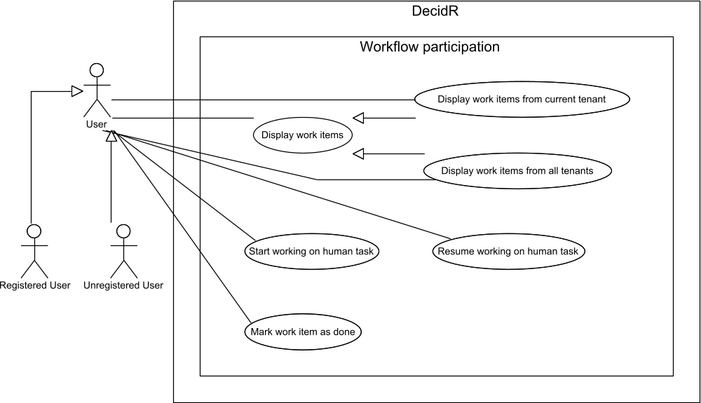
Figure 24 use case overview “workflow partification”

Display work items from current tenant
Priority | Must-have
Reference | Figure 7: my workitems
Goal | The user wants to view his work items of the current tenant.
Precondition | - The user has logged in.  - The user is member of at least one tenant.
Basic flow | - The user clicks on the „My Workitems” entry in the navigation bar or select in the combo box on the work item page “current tenant”.  - The system displays a list of the user’s work items for the actual. For every work item the following data is displayed:  - Name  - Tenant  - Date received  - Due date  - Status (new, in progress or done)  Work items with the status „new” are displayed with a link „work on item“. Work items with the status „in progress“ are displayed with a link „work on it“ and with a link „mark as done“.
Postcondition | - The user can see the work items of the current tenant.  - The user is logged in.

Display work items from all tenants
Priority | Must-have
Reference | Figure 7: my workitems
Goal | The user wants to view his work items of all tenants.
Precondition | - The user has logged in  - The user is member of at least two tenants.
Basic flow | - Execute use case View list of tenant workflow models  - The user select in the combo box on the work item page “all tenants”.  - The system displays a list of the user’s work items for all tenants. For every work item the following data is displayed:  - Name  - Tenant  - Date received  - Due date  - Status (new, in progress or done)  Work items with the status „new” are displayed with a  link „work on it “. Work items with the status „in  progress“ are displayed with a link „work on it “ and  with a link „mark as done“.
Postcondition | - The user can see the work items of the current tenant.  - The user is logged in.

Start Working on Human Task
Priority | Must-have
Reference | Figure 7: my workitems
Goal | The user wants to start working on a work item.
Precondition | - The user is member of at least one tenant.  - The system displays the user’s work items.  - At least one work item has the status „new“.
Basic flow | - The user clicks on the link „work on it” of that work item, he wishes to work on.  - The system opens a new window that contains one or more of the following items:  - Text fields  - Forms  - Input fields  Content, Size and amount are defined by the tenant admin and the workflow admin. The window can also include the possibility to upload one ore more files.  - The user fills out the forms, input fields and/or uploads a file.  - The user clicks on the button „Save“.  - The system saves the state and inputs of the windows and closes the windows. The system changes the status of the work item to „in progress“.  - The system displays the user’s work items
Postcondition | - The work item status is displayed as „in progress“.  - State and inputs made by the user are saved into the  system.  - The user’s work items are shown.

Resume Working on Human Task
Priority | Must-have
Reference | Figure 7: my workitems
Goal | The user wants resume work on a work item.
Precondition | - The user is member of at least one tenant.  - The system displays the user’s work items.  - At least one work item has the status „in progress“.  - The user is logged in.
Basic flow | - The user clicks on the link „work on it “ of that work item he wishes to work on.  - The system opens a new window that contains one or more of the following items:  - Text fields  - Forms  - Input fields  Content, Size and amount are defined by the tenant admin and the workflow admin. The window can also include the possibility to upload a file. If available, the input fields are filled by the previously generated content oft he user.  - The user fills out the forms, input fields and/or uploads one or more files.  - The user click on the button „Save“.  - The system saves the state and inputs of the window and closes the window.
Postcondition | - The work item status is displayed as „in progress“.  - State and inputs done by the user are saved into the  system.  - The user is logged in.

Mark Work Item As Done
Priority | Must-have
Reference | Figure 7: my workitems
Goal | The user wants to mark a work item as done.
Precondition | - The user is member of at least one tenant.  - The system displays the user’s work items.  - At least one work item has the status „in progress“.  - The user is logged in.
Basic flow | - The user clicks on the link „mark as done” of that work item, he or she wishes to mark as done.  - The system marks the work item as done by changing the status from „in progress” to "done".
Postcondition | - The work item status in displayed as „done“.  - The user cannot work on that work item anymore.  - The user is logged in.

Workflow instance management

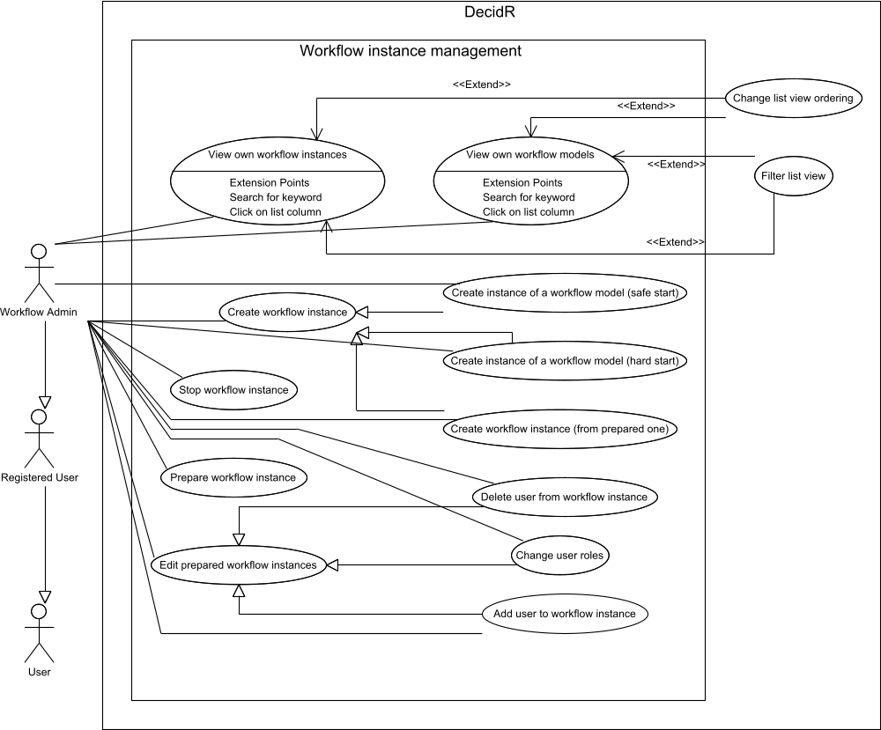
Figure 25 use case overview “workflow instance management”

View own workflow models
Priority | Must-have
Reference | Figure 10: create workflow instance
Goal | The workflow admin wants to list his own workflow models
Precondition | The workflow admin is logged in.
Basic flow | - The workflow admin clicks on the link “create instance”.  - A page is shown where all workflow models of the workflow admin for the current tenant are listed.
Postcondition | - A page with all workflow models of the workflow admin for  the current tenant is shown.  - The workflow admin is logged in.

View own workflow instances
Priority | Must-have
Reference | Figure 11: show workflow instances
Goal | The workflow admin wants to list his own workflow instances.
Precondition | The workflow admin is logged in.
Basic flow | - The workflow admin clicks on the link “ show workflow instances”  - A page is shown where all workflow models of the workflow admin for the current tenant are listed.
Postcondition | - A page with all workflow instances of the workflow admin is  shown.  - The workflow admin is logged in.

Prepare workflow instance
Priority | Nice-to-have
Reference | None.
Goal | The workflow admin wants to prepare an instance from a workflow model.
Precondition | The workflow admin is logged in.
Basic flow | - The workflow admin clicks on the link “create workflow instance”.  - The workflow admin selects a model from which he wants to create an instance and presses the “prepare” button.  - The workflow admin invites or adds at least one user to the instance (see Add user to a workflow instance)  - The workflow admin presses the button “save”.  - The system shows a success page.
Postcondition | - An instance of the workflow is created and set to the status  prepared.  - The workflow admin is logged in.

Create instance of a workflow model (safe start)
Priority | Must-have
Reference
Goal | The workflow admin wants to create an instance from a workflow model.
Precondition | The workflow admin is logged in.
Basic flow | - The workflow admin goes to the workflow model overview page  - The workflow admin selects a model from which he wants to create an instance and click on the link “start instance”.  - The workflow admin invites or adds at least one user to the instance (see Add user to a workflow instance) and sets the model specific variables.  - The system checks if “start with unregistered users” is selected – result: yes  - The system sends invitations to unregistered users and who are not member of the tenant.  - The system checks if all users are active – result: yes  - The system checks if all workflow roles are assigned – result: yes  - System creates a workflow instance, set the status to active and starts a BPEL process with this workflow.
Postcondition | - An instance of and workflow is created and set to the status  running.  - A BPEL instance was started.  - The workflow admin is logged in.
Alternative flow (1) | 4a.The system checks if “start with unregistered users” is  selected – result: no  5a. The system checks if all users are registered – result:  yes  6a. Continue with step 6
Alternative flow (1-1) | 5aa. The system checks if all users are registered –  result: no  6aa. The system shows a notification, that not all users  are registered.  7aa. Continue with step 3
Alternative flow (2) | 6a. The System checks if all users are active – result: no  7a. An error message is shown “Users x,y,... are inactive”.  8a. Continue with step 3.
Alternative flow (3) | 7a. The system checks if all workflow roles are assigned –  result: no  8a. The system shows an warning page “not all roles  assigned” and ask the user if we wants to start the  workflow anyway – result yes  9a. Continue with step 8.
Alternative flow (3-1) | 8aa. The system shows an warning page “not all roles  assigned” and ask the user if we wants to start the  workflow anyway – result no  9aa. Continue with step 3.

Create instance of a workflow model (hard start)
Priority | Must-have
Reference | Figure 10: create workflow instance
Goal | The workflow admin wants to create an instance from a workflow model.
Precondition | The workflow admin is logged in.
Basic flow | - The workflow admin goes to the workflow model overview page.  - The workflow admin selects a model from which he wants to create an instance.  - The workflow admin invites or adds ad least one user to the instance and set se model specific variables.  - The System checks if “start without inactive users” is selected – result: yes  - The workflow admin presses the button start.
Postcondition | - An instance of and workflow is created and set to the status  running.  - The workflow admin is logged in.

Create workflow instance (from prepared one)
Priority | Nice-to-have
Reference | Figure 10: create workflow instance
Goal | The workflow admin wants to start a workflow instance from a prepared one.
Precondition | The workflow admin is logged in.
Basic flow | - The workflow admin goes to the workflow instance overview page, selects an instance which is in the prepared state and presses the edit link.  - The system shows the instance editing page.  - The workflow admin presses the button start instance.  - Execute use case Create instance of a workflow model (safe start) or Create instance of a workflow model (hard start)
Postcondition | - The instance of the workflow is started.  - The workflow admin is logged in.

Change User roles
Priority | Must-have
Reference | None.
Goal | The workflow admin wants to chance the role of an already added user in a workflow instance.
Precondition | - The workflow admin is logged in.  - Editing page of an instance is shown.
Basic flow | - The system shows a page where all users are listed. Next to each user there is a combo box with the roles.  - The workflow admin changes the role of one or more users and press the save button.  - The system changes the user roles.
Postcondition | - The user roles of the users were changed.  - The workflow admin is logged in.

Add user to a workflow instance
Priority | Must-have
Reference | None.
Goal | The workflow admin wants to add a user to a workflow instance.
Precondition | - The workflow admin is login in.  - The system shows an editing page of an instance.
Basic flow | - The workflow admin presses the button add user.  - A text field is shown.  - The workflow admin enters a user which is member of the tenant or an email address and select the role in the combo box  - The system checks if an email address or an tenant user is entered – result: tenant user  - System adds user to the instance and set the assigned role
Postcondition | - User was added and corresponding role was set.  - The workflow admin is logged in.
Alternative flow (1) | 6a. The system checks if an email address or an tenant  user is entered – result: email address  7a. If the email address isn’t registered a register link as  normal user is sent and after registration the user is  assigned to the specific role, if not, user with the  corresponding email address was added and the role  is assigned.
Alternative flow (2) | 5a The system checks if an email address or an tenant  user is entered – neither email nor tenant user  6a. The system shows an error message.
Alternative postcondition (1) | - User was added and corresponding role was set.  - The workflow admin is logged in.
Alternative postcondition (2) | - User wasn’t added.  - The workflow admin is logged in.

Delete user from an workflow instance
Priority | Must-have
Reference | None.
Goal | The workflow admin wants to chance the role of an already added user in an prepared workflow instance
Precondition | - The workflow admin is login in.  - Editing page of an instance is shown.
Basic flow | - The workflow admin goes to the workflow instance overview page and select an instance which is in the prepared running  - The workflow admin presses the button delete user  - A page is shown where all users are listed. Next to each user there is a button “delete user”.  - The workflow admin clicks on one of the buttons.  - The system deletes the relation between the user and the instance.
Postcondition | - The user is no longer part of the instance.  - The workflow admin is logged in.

Stop workflow instance
Priority | Must-have
Reference | Figure 11: show workflow instances
Goal | The workflow admin wants to stop a running instance.
Precondition | The workflow admin is login in.
Basic flow | - The workflow admin goes to the workflow instance overview page and select an instance which is in the prepared running  - The workflow admin presses the button “stop”.  - The system asks again if the workflow should really stop.  - The workflow admin confirms his choice.  - The system stops the instance.  - The system terminates the BPEL process.
Postcondition | - The instance of the workflow is stopped.  - The workflow admin is logged in.  - The BPEL process is terminated.
Alternative flow | 4a The workflow admin reject his choice.
Alternative postcondition | - The instance of the workflow isn’t stopped.  - The workflow admin is logged in.

Tenant settings
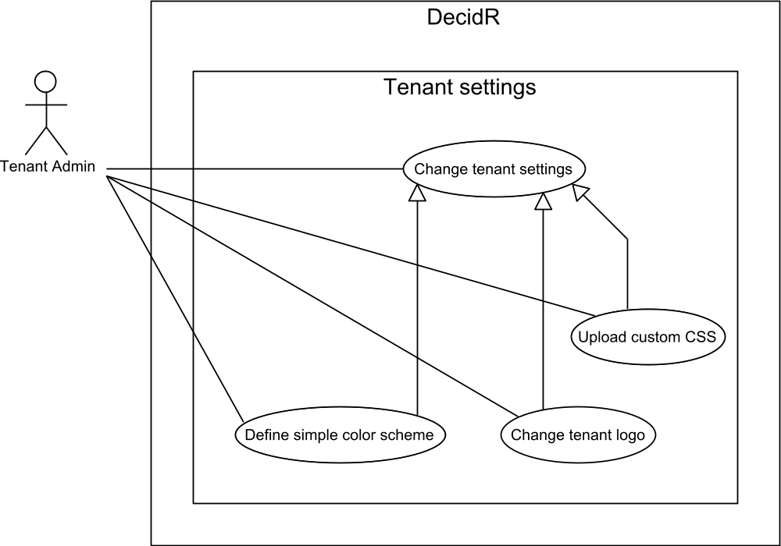
Figure 26 use case overview “tenant settings”

Change tenant settings
Priority | Must-have
Reference | Figure 15: tenant settings (simple)  Figure 16: tenant settings (advanced)
Goal | The tenant admin wants to change the tenant description, set a tenant logo or make changes to the tenant color scheme.
Precondition | The tenant admin is logged in.
Basic flow | - The tenant admin navigates to the tenant settings page by selecting “Tenant Settings” in the navigation bar. The system displays the current settings in the web browser.  - The tenant admin enters a new description text and optionally changes the tenant appearance settings (see specialized use cases).  - The tenant admin presses the save button.  - The system validates the new settings. All settings are valid.  - The system stores the new settings and displays the updated settings page in the web browser.
Postcondition | The new settings have been written to the database.
Alternative flow (1) | 4a. The description text is too long or the appearance settings are invalid (see specialized use cases).  5a. The system displays an error message.
Alternative postcondition (1) | The tenant admin is logged in.  The web browser displays an error message. The tenant admin may continue with step 4.
Alternative flow (2) | 4a. The tenant has been deleted by the super admin.  5a. The system displays an error message in the web browser.
Alternative postcondition  (2) | The web browser displays an error message.

Change tenant logo
Priority | Must-have
Reference | Figure 15: tenant settings (simple)  Figure 16: tenant settings (advanced)
Goal | The tenant admin wants to change the logo that is displayed to every user of the tenant once they’re logged in.
Precondition | The tenant admin is logged in.
Basic flow | - The tenant admin navigates to the tenant settings page by selecting “Settings” in the navigation bar.  - The system displays the current logo in the web browser.  - The tenant admin selects a file on his local system to use as the new tenant logo.  - The tenant admin presses the save button on the settings page.  - The system verifies the new settings submitted by the tenant admin. The new tenant logo file does not exceed the file size limit and is a valid image file.  - If necessary, the system resizes the image so it doesn’t exceed the maximum tenant logo dimensions.  - The system overwrites the current tenant logo with the new image file.  - The system displays the updated tenant settings page in the web browser.
Postcondition | The tenant admin is logged in.  The tenant admin’s web browser displays the updated settings page.  The new tenant logo is displayed.
Alternative flow | 4a. The submitted file is too large or does not contain a valid image.  5a. The system displays an error message.
Alternative postcondition | The tenant admin is logged in.  The old tenant logo hasn’t been overwritten.  The web browser displays an error message. The tenant admin may continue with step 3.

Upload custom CSS

Priority | Desirable
Reference | Figure 16: tenant settings (advanced)
Goal | The tenant admin wants to upload his own CSS file that defines the appearance of the web pages for all users of that tenant.
Precondition | The tenant admin is logged in.
Basic flow | - The tenant admin navigates to the tenant settings page by selecting “Settings” in the navigation bar.  - The system displays the current appearance settings.  - The tenant admin selects “show advanced options” if he hadn’t previously used a CSS file to define the tenant appearance. Otherwise the web browser already displays the CSS input box.  - The tenant admin enters his CSS code into the input box.  - The tenant admin presses the save button.  - The system successfully validates the CSS.  - The system overwrites the current tenant CSS file with the new custom CSS file.  - The system displays the updated settings page in the web browser.
Postcondition | The tenant admin is logged in.  The web browser displays the updated settings page.  The tenant web pages use the new color scheme.
Alternative flow | 6a. The CSS is not valid.  7a. The system displays an error message.
Alternative postcondition | The tenant admin is logged in.  The web browser displays an error message. The user may continue with step 4.  The tenant color schema hasn’t changed.

Define simple color scheme

Priority | Must-have
Reference | Figure 15: tenant settings (simple)
Goal | The tenant admin wants to change the tenant appearance using user-friendly color input boxes.
Precondition | The tenant admin is logged in.
Basic flow | - The tenant admin navigates to the tenant settings page by selecting “Settings” in the navigation bar.  - The system displays the current appearance settings.  - The tenant admin selects “show basic options” if he had previously used a CSS file to define the tenant appearance. The web browser displays the basic color scheme input boxes.  - The tenant admin uses the color input boxes to define the new color scheme.  - The tenant admin presses the save button.  - The system generates a CSS file from the user’s input and overwrites the current tenant CSS file with the generated file.  - The system displays the updated settings page in the web browsers.
Postcondition | The tenant admin is logged in.  The web browser displays the updated settings page.  The tenant web pages use the new color scheme.

Tenant user management
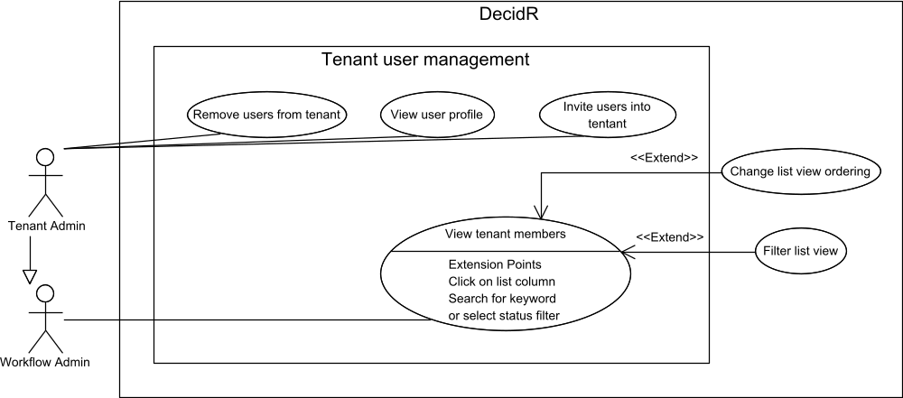
Figure 27 use case overview “tenant user management”

Invite users to tenant
Priority | Must-have
Reference | Figure 17: edit user list (tenant admin)
Goal | The tenant admin wants to send invitation e-mails to registered or unregistered users that allow the users to join the tenant as normal users.
Precondition | The tenant admin is logged in.
Basic flow | - The tenant admin navigates to the user administration page by selecting “Edit user list” in the navigation bar.  - The tenant admin navigates to the invitation sub-page.  - The tenant admin selects “invite user”.  - The system displays an input box in the web browser.  - The tenant admin enters up to <INVITE_LIMIT> addresses or DecidR usernames.  - The tenant admin presses the send button.  - The system verifies the given e-mail addresses and usernames. All e-mail addresses are valid and all usernames denote registered DecidR users that aren’t already members of the tenant.  - The system sends invitation e-mails to the given e-mail addresses which it deduces from the usernames if necessary. If user profile information is available, the system uses it to enhance the content of the invitation (such as addressing the users with their actual name).  - The system displays a success message in the web browser.
Postcondition | The tenant admin is logged in.  The web browser displays a success message.  Invitation e-mails have been sent to the given e-mail addresses.  Every registered DecidR user receives at most one invitation e-mail.
Alternative flow (1) | 7a. At least one of the following errors occurs:  - At least one e-mail address is invalid.  - At least one username doesn’t denote a registered DecidR user.  - At least one e-mail address or username belongs to a registered user who is already a member of the tenant.  - The tenant admin submits too many usernames / e-mail addresses.  8a. The system displays an error message in the browser. The tenant admin may continue with step 5.
Alternative postcondition (1) | The tenant admin is logged in.  The web browser displays an error message.  The system hasn’t sent any invitation e-mails.
Alternative flow (2) | 6a. The tenant has been deleted by the super admin.  7a. The system displays an error message in the web browser.
Alternative postcondition  (2) | The tenant admin is logged in.  The web browser displays an error message.

Remove users from tenant
Priority | Must-have
Reference | Figure 17: edit user list (tenant admin)
Goal | The tenant admin wants to remove one or more users from the tenant.
Precondition | The tenant admin is logged in.  There is at least one tenant member besides the tenant admin.
Basic flow | - The tenant admin navigates to the user administration by selecting “Edit users” in the navigation bar.  - The system displays a list of tenant members.  - The tenant admin selects one or more tenant members to remove.  - The tenant admin presses the remove button.  - The system displays a confirmation dialog in the web browser.  - The tenant admin confirms the removal.  - The system checks whether any of the users to remove can actually be removed. This is the case.  - The system revokes the tenant membership status of the selected users.  - The system displays the updated list of tenant members in the web browser.
Postcondition | The tenant admin is logged in.  The selected users are no longer members of the tenant, but may still be members of other tenants.  The web browser displays the updated list of tenant members.
Alternative flow (1) | 6a. The tenant admin cancels the removal.
Alternative postcondition (1) | The tenant admin is logged in.  There is at least one tenant member besides the tenant admin unless that tenant member has left the tenant in the mean time.
Alternative flow (2) | 7a. At least one tenant member cannot be removed because he has left the tenant on his own, is participating in a workflow, administrating the workflow, or is the tenant admin himself.  8a. The system displays an error message in the web browser. The tenant admin may continue with step 3.
Alternative postcondition (2) | The tenant admin is logged in.  The web browser displays an error message. The tenant admin may continue with step 3.  None of the selected tenant members have been removed.
Alternative flow (3) | 6a. The tenant has been deleted by the super admin.  7a. The system displays an error message in the web browser.
Alternative postcondition (3) | The web browser displays an error message.

View tenant members
Priority | Must-have
Reference | Figure 17: edit user list (tenant admin)
Goal | The workflow admin wants to view a list of tenant members.
Precondition | The workflow admin is logged in.
Basic flow | - The workflow admin navigates to the user administration by selecting “Users” in the navigation bar.  - The system displays a list of tenant members in the web browsing using the default ordering.
Postcondition | The tenant admin is logged in.  The web browser displays a list of tenant members.

View user profile
Priority | Desirable
Reference | Figure 17: edit user list (tenant admin)
Goal | The tenant admin wants to view the profile data of a tenant member.
Precondition | The tenant admin is logged in.
Basic flow | - The tenant admin navigates to the user administration by selecting “Users” in the navigation bar.  - The system displays the tenant member list.  - The tenant admin selects a tenant member.  - The system displays in the web browser:  - The tenant member’s profile data  - A list of workflow instances that tenant member is participating in  - A list of workflow models that are administrated by the tenant member
Postcondition | The tenant admin is logged in.  The web browser displays the tenant member’s profile data.
Alternative flow | 2a. The selected user is no longer a member of the tenant.  3a. The system displays an error message in the web browser.
Alternative postcondition | The tenant admin is logged in.

Workflow modeling
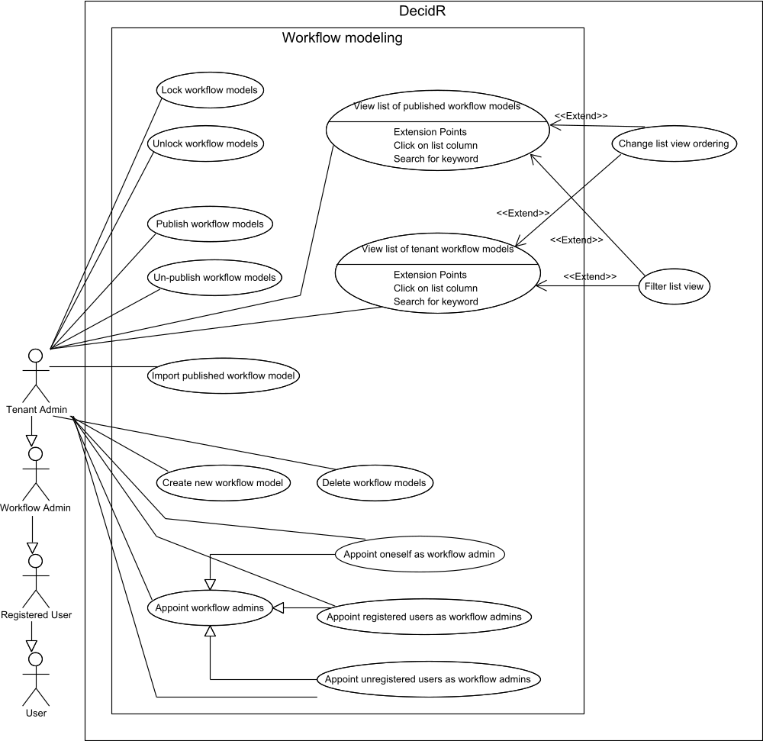
Figure 28 use case overview “workflow modeling”

Create new workflow model
Priority | Must-have
Reference | Figure 13: workflow model view (current tenant)
Goal | The tenant admin wants to create a new workflow model.
Precondition | The tenant admin is logged in.
Basic flow | - The tenant admin navigates to the workflow modeling section by clicking on the “create / edit workflow models” navigation link.  - The system displays a list of workflow models in the web browser.  - The tenant admin presses the “Create new model” button.  - The system displays an input box named “New workflow model name”.  - The tenant admin enters a workflow model name and presses the OK button.  - The system successfully validates the given name.  - The system creates a new workflow model with the given name.  - The system displays the new workflow model in the workflow model editor.
Postcondition | The tenant admin is logged in.  The system has created a new workflow model with the given name.  The web browser displays the workflow model editor where the new workflow model has been opened for editing.
Alternative flow (1) | 6a. The given name is invalid.  7a. The system displays an error message in the web browser. The user may continue with step 5.
Alternative postcondition (1) | The tenant admin is logged in.  The browser displays an error message.  The system has not yet created the new workflow model  The use may continue with step 5.
Alternative flow (2) | 6a. The tenant has been deleted by the super admin.  7a. The system displays an error message.
Alternative postcondition (2) | The tenant admin is logged in.  The tenant has been deleted.

Delete workflow models
Priority | Must-have
Reference | Figure 13: workflow model view (current tenant)
Goal | The tenant admin wants to delete one or more existing workflow models.
Precondition | The tenant admin is logged in.  The tenant owns at least one workflow model.
Basic flow | - The tenant admin navigates to the workflow modeling section by clicking on the “create / edit workflow models” navigation link.  - The system displays a list of workflow models in the web browser.  - The tenant admin selects one or more workflow models to delete.  - The tenant admin presses the remove button.  - The system displays a confirmation dialog in the web browser.  - The tenant admin confirms the deletion.  - The system removes the selected workflow models, but keeps all workflow instances that have been created from the deleted model.  - The system displays the updated workflow model list in the web browser.
Postcondition | The tenant admin is logged in.  The selected workflow models have been deleted.  The web browser displays the updated workflow model list.
Alternative flow (1) | 6a. The tenant admin cancels the deletion.
Alternative postcondition (1) | The tenant admin is logged in.  The selected workflow models still exist.  The web browser displays the workflow model list.
Alternative flow (2) | 7a. At least one selected workflow model cannot be deleted because it doesn’t exist anymore.  8a. The system ignores the non-existent model and deletes the remaining selected workflow models. Continue with step 8.

Lock workflow models
Priority | Must-have
Reference | Figure 13: workflow model view (current tenant)
Goal | The tenant admin wants to lock existing workflow models so no new instances can be created from them until they are unlocked.
Precondition | The tenant admin is logged in.  The tenant owns at least one workflow model.
Basic flow | - The tenant admin navigates to the workflow modeling page by clicking on the “create / edit workflow models” navigation link.  - The system displays a list of workflow models in the web browser.  - The tenant admin selects a set of workflow models to lock.  - The tenant admin presses the lock button.  - The system locks each selected workflow model.  - The system displays the updated workflow modeling page in the web browser.
Postcondition | The tenant admin is logged in.  The web browser displays the updated workflow model list.  No new workflow instances can be created from the selected workflow models.
Alternative flow (1) | 5a. At least one of the selected workflow models doesn’t exist anymore.  6a. The system ignores the nonexistent workflow models and locks the remaining ones. Continue with step 6.

Unlock workflow models
Priority | Must-have
Reference | Figure 13: workflow model view (current tenant)
Goal | The tenant admin wants to unlock existing workflow models so new instances can be created from them.
Precondition | The tenant admin is logged in.  The tenant owns at least one workflow model.
Basic flow | - The tenant admin navigates to the workflow modeling page by clicking on the “create / edit workflow models” navigation link.  - The system displays a list of workflow models in the web browser.  - The tenant admin selects a set of workflow models to unlock.  - The tenant admin presses the unlock button.  - The system unlocks each selected workflow model.  - The system displays the updated workflow modeling page in the web browser.
Postcondition | The tenant admin is logged in.  The web browser displays the updated workflow model list.  New workflow instances can be created from the selected workflow models.
Alternative flow (1) | 5a. At least one of the selected workflow models doesn’t exist anymore.  6a. The system ignores the nonexistent workflow models and unlocks the remaining ones. Continue with step 6.

Import published workflow model
Priority | Must-have
Reference | Figure 14: workflow model view (public models)  View list of published workflow models
Goal | The tenant admin wants to import a published workflow model so he may edit them and start new workflow instances from them.
Precondition | The tenant admin is logged in.  The web browser is displaying the list of published workflow models.
Basic flow | - The tenant admin selects the published workflow model to import.  - The tenant admin presses the import button.  - The system creates a copy of the selected workflow model that is owned by the tenant admin.  - The system displays the list of published workflow models along with a success message.
Postcondition | The tenant admin is logged in.  The web browser displays the list of published workflow models and a success message.

Publish workflow models
Priority | Must-have
Reference | Figure 13: workflow model view (current tenant)
Goal | The tenant admin wants to publish one or more of his workflow models, so other tenant admins may view and import them.
Precondition | The tenant admin is logged in.
Basic flow | - The tenant admin navigates to the workflow modeling page by clicking on the “create / edit workflow models” navigation link.  - The system displays a list of workflow models in the web browser.  - The tenant admin selects a set of workflow models to publish.  - The tenant admin presses the publish button.  - The system flags the selected workflow models as published.  - The system displays the updated list of workflow models in the web browser.
Postcondition | The tenant admin is logged in.  The web browser displays the updated list of workflow models that the tenant admin owns.  The selected workflow models are now visible to other tenant admins, who may view or import them.

Un-publish workflow models
Priority | Must-have
Reference | Figure 13: workflow model view (current tenant)
Goal | The tenant admin wants to un-publish one or more of his workflow models, so other tenant admins can no longer view and import them.
Precondition | The tenant admin is logged in.
Basic flow | - The tenant admin navigates to the workflow modeling page by clicking on the “create / edit workflow models” navigation link.  - The system displays a list of workflow models in the web browser.  - The tenant admin selects a set of workflow models to un-publish.  - The tenant admin presses the un-publish button.  - The system removes the published flag from each selected workflow model.  - The system displays the updated list of workflow models in the web browser.
Postcondition | The tenant admin is logged in.  The web browser displays the updated list of workflow models that the tenant admin owns.  The selected workflow models are no longer visible to other workflow admins, nor can they be imported.

View list of tenant workflow models
Priority | Must-have
Reference | Figure 13: workflow model view (current tenant)
Goal | The tenant admin wants to view a list of workflow models that he owns.
Precondition | The tenant admin is logged in.
Basic flow | - The tenant admin navigates to the workflow modeling page by clicking on the “create / edit workflow models” navigation link.  - The system displays a list of workflow models in the web browser.
Postcondition | The tenant admin is logged in.  The web browser displays the list of workflow models that the tenant admin owns.

View list of published workflow models
Priority | Must-have
Reference | Figure 14: workflow model view (public models)
Goal | The tenant admin wants to view a list of workflow models which are not owned by the tenant, but have been published by other tenants.
Precondition | The tenant admin is logged in.
Basic flow | - The tenant admin navigates to the workflow modeling page by clicking on the “create / edit workflow models” navigation link.  - The system displays a list of workflow models in the web browser.  - The tenant admin clicks on the “Other tenants” tab.  - The system displays a list of workflow models that have been published by other tenants.
Postcondition | The tenant admin is logged in.  The web browser displays the list of published workflow.

Appoint workflow admins
Priority | Must-have
Reference | Figure 13: workflow model view (current tenant)
Goal | The tenant admin wants to designate one or more users as the workflow administrators for a particular workflow model.
Precondition | The tenant admin is logged in.  The tenant admin has created at least one workflow model.
Basic flow | - The tenant admin navigates to the workflow models page by selecting “Models” in the navigation bar.  - The system displays a list of the tenant’s workflow models in the web browser.  - The tenant admin selects a workflow model and then chooses “appoint workflow admins”.  - The system displays an input box in the web browser.  - The tenant admin chooses from one of the following options:  - Appoint oneself as the workflow admin.  - Enter the usernames of registered DecidR users.  - Enter the e-mail addresses of the desired workflow admins.  - The tenant admin presses the OK button.  - The system processes the tenant admin’s input (see specialized use cases).
Postcondition | The tenant admin is logged in.  The tenant admin has created at least one workflow model.
Alternative flow | 6a. The workflow model doesn’t exist anymore.  7a. The system displays an error message in the web browser.
Alternative postcondition | The web browser displays an error message.

Appoint oneself as workflow admin
Priority | Must-have
Reference | Figure 13: workflow model view (current tenant)
Goal | The tenant admin wants to designate himself as the workflow administrator for a particular workflow model.
Precondition | The tenant admin is logged in.  The tenant admin has created at least one workflow model.
Basic flow | - The tenant admin navigates to the workflow models page by selecting “Models” in the navigation bar.  - The system displays a list of the tenant’s workflow models in the web browser.  - The tenant admin selects a workflow model and then chooses “appoint workflow admins”.  - The system displays an input box in the web browser.  - The tenant admin chooses “just me” as the workflow admin.  - The tenant admin presses the OK button.  - The system makes the tenant admin the workflow admin of the selected workflow model.  - The system displays the updated workflow models page.
Postcondition | The tenant admin is logged in.  The tenant admin has created at least one workflow model.  The tenant admin is the workflow admin of the selected workflow model.

Appoint registered user as workflow admins
Priority | Must-have
Reference | Figure 13: workflow model view (current tenant)
Goal | The tenant admin wants to designate registered users as the workflow administrators for a particular workflow model.  There is at least one tenant member besides the tenant admin.
Precondition | The tenant admin is logged in.  The tenant admin has created at least one workflow model.  There is at least one tenant member besides the tenant admin.
Basic flow | - The tenant admin navigates to the workflow models page by selecting “Models” in the navigation bar.  - The system displays a list of the tenant’s workflow models in the web browser.  - The tenant admin selects a workflow model and then chooses “appoint workflow admins”.  - The system displays an input box in the web browser.  - The tenant admin enters the usernames of registered users or selects members of the tenant.  - The tenant admin presses the OK button.  - The system sends an e-mail to each specified registered user. If the registered user is already a member of the tenant, the e-mail simply informs the user about his workflow admin status. Otherwise, each registered user must confirm joining the tenant first by following a link that is included in the e-mail.  - The system displays the updated workflow models page.
Postcondition | The tenant admin is logged in.  There is at least one tenant member besides the tenant admin.  The tenant admin has created at least one workflow model.  For each registered user: if the specified registered user is a member of the tenant:  - The tenant member is the workflow admin of the selected workflow model.  - The system has sent an info e-mail to the tenant member.  Otherwise:  - The system has sent an invitation e-mail that allows the registered user to become the workflow admin for the selected workflow model upon joining the tenant.  - The system hasn’t changed the workflow admin of the selected workflow model yet
Alternative flow | 7a. At least one given username does not belong to a registered user or the registered user has set his status to “unavailable”.  8a. The system displays an error message in the web browser. The tenant admin may continue with step 5.
Alternative postcondition | The tenant admin is logged in.  The tenant admin has created at least one workflow model.  There is at least one tenant member besides the tenant admin.  The web browser displays an error message.  The tenant admin may continue with step 5.  The system hasn’t changed the workflow admins of the selected workflow.

Appoint unregistered users as workflow admins
Priority | Must-have
Reference | Figure 13: workflow model view (current tenant)
Goal | The tenant admin wants to designate users of whom he only knows the e-mail addresses as the workflow administrators for a particular workflow model.
Precondition | The tenant admin is logged in.  The tenant admin has created at least one workflow model.
Basic flow | - The tenant admin navigates to the workflow models page by selecting “Models” in the navigation bar.  - The system displays a list of the tenant’s workflow models in the web browser.  - The tenant admin selects a workflow model and then chooses “appoint workflow admins”.  - The system displays an input box in the web browser.  - The tenant admin enters up to LIMIT e-mail addresses.  - The tenant admin presses the OK button.  - The system verifies each given e-mail addresses. They are valid and do not belong to a registered user.  - The system sends in invitation e-mail to the given address.  - The system displays the updated workflow models page.
Postcondition | The tenant admin is logged in.  The tenant admin has created at least one workflow model.  The system has sent e-mails containing an invitation links to the given addresses.  The system hasn’t changed the workflow admin of the selected workflow model yet
Alternative flow (1) | 7a. A given e-mail address belongs to a registered user.  8a. Continue with step 7 of “Appoint registered user as workflow admins”.
Alternative flow (2) | 7a. The e-mail address is invalid.  8a. The system displays an error message. The tenant admin may continue with step 5.
Alternative postcondition (2) | The tenant admin is logged in.  The tenant admin has created at least one workflow model.  The web browser displays an error message.  The tenant admin may continue with step 5.  The system hasn’t changed the workflow admin of the selected workflow.

Workflow model editor
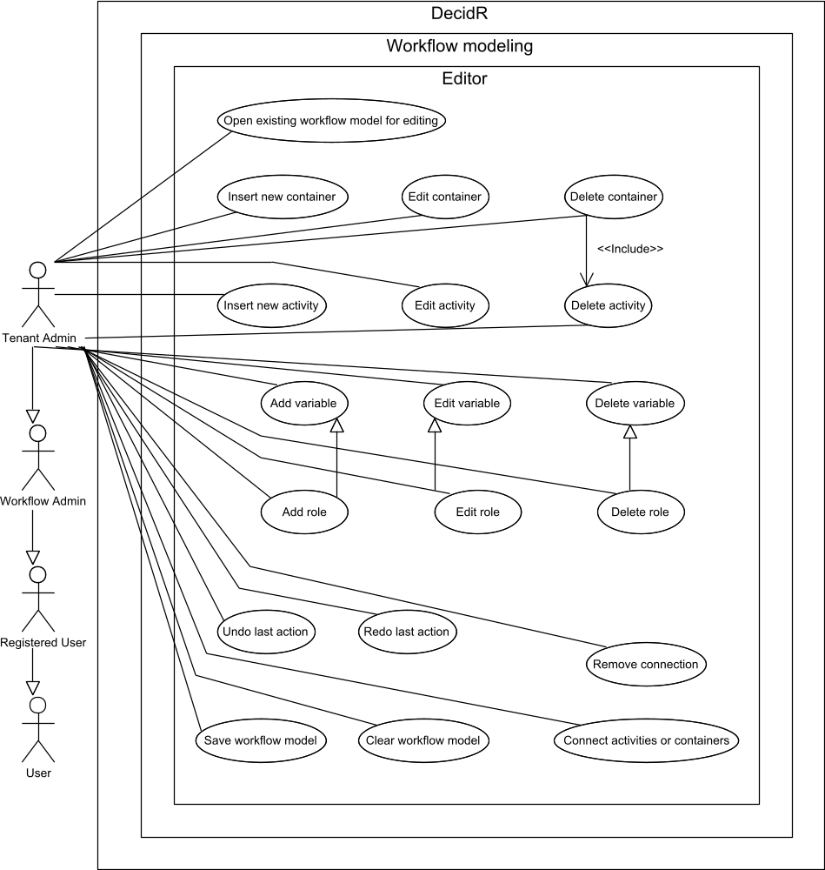
Figure 29 use case overview “workflow model editor”

Open existing workflow model for editing
Priority | Must-have
Reference | Figure 13: workflow model view (current tenant)
Goal | The tenant admin wants to open the workflow model editor in order to start modifying an existing workflow model.
Precondition | The tenant admin is logged in.  The tenant owns at least one workflow model.
Basic flow | - The tenant admin navigates to the workflow modeling page by clicking on the “create / edit workflow models” navigation link.  - The system displays a list of workflow models in the web browser.  - The tenant admin clicks on a workflow model name.  - The system opens the workflow model editor in the web browser showing the selected workflow model.
Postcondition | The tenant admin is logged in.  The tenant owns at least one workflow model.  The web browser displays the selected workflow model in the editor.
Alternative flow | 4a. The selected workflow model doesn’t exist anymore.  5a. The system displays an error message in the web browser.
Alternative postcondition | The web browser displays an error message.

Save workflow model
Priority | Must-have
Reference | None.
Goal | The tenant admin wants to save the changes he has made to a workflow model.
Precondition | The tenant admin is logged in.  The tenant admin has opened an existing workflow for editing.
Basic flow | - The tenant admin presses the save button in the editor.  - The system saves the modified workflow model.  - The tenant admin may continue editing the workflow model.
Postcondition | The tenant admin is logged in.  The system has saved the modified workflow model.  The web browser is displaying the workflow model editor.
Alternative flow (1) | 2a. The system cannot save the workflow model because it has been deleted or it contains invalid data.  3a. The system displays an error message in the web browser.
Alternative postcondition (1) | The tenant admin is logged in.  The web browser displays an error message.
Alternative flow (2) | 2a. The system cannot save the workflow model because it belongs to another tenant and has been published.  3a. The system displays a dialog in the web browser asking the tenant admin if the workflow model should be imported.  4a. The tenant admin confirms.  5a. The system saves the published workflow including all modifications made by the tenant admin as a new workflow model that is owned by the tenant.
Alternative postcondition (2) | The tenant admin is logged in.  The system has saved the modified workflow model as a new tenant-owned model.  The system hasn’t changed the published workflow model that was initially opened for editing.  The tenant admin is now editing the imported workflow model.
Alternative flow (2-1) | 4aa. The tenant admin cancels.
Alternative postcondition (2-1) | The tenant admin is logged in.  The system hasn’t changed the published workflow model.  The system hasn’t created a new tenant-owned workflow model.

Clear workflow model
Priority | Must-have
Reference | None.
Goal | The tenant admin wants to remove all activities, containers, connections and variables from the currently opened workflow model and start from scratch.
Precondition | The tenant admin is logged in.  The tenant admin has opened an existing workflow for editing.
Basic flow | - The tenant admin presses the clear button.  - The system displays a confirmation dialog.  - The tenant admin confirms clearing the model.  - The editor deletes all activities, containers, connections and variables in the currently opened workflow model, and then recreates the start and end activities with default values.  - The tenant admin may continue editing the workflow model.
Postcondition | The tenant admin is logged in.  The tenant admin has opened an existing workflow for editing.  The editor has deleted all activities, containers, connections and variables.  The system hasn’t saved the cleared workflow model.
Alternative flow | 3a. The tenant admin cancels clearing the model.
Alternative postcondition | The tenant admin is logged in.  The tenant admin has opened an existing workflow for editing.  The editor hasn’t deleted any activities, containers, variables or connections.

Insert new activity
Priority | Must-have
Reference | None.
Goal | The tenant admin wants to insert one of the available activities into the workflow model. See chapter 4.3 Activities for a list of available activities.
Precondition | The tenant admin is logged in.  The tenant admin has opened an existing workflow for editing.
Basic flow | - The tenant admin drags an activity icon from the palette onto the canvas.  - The editor adds the new activity to the workflow model and opens its properties for editing.
Postcondition | The tenant admin is logged in.  The tenant admin has opened an existing workflow for editing.  The editor displays the properties of the new activity.

Insert new container
Priority | Must-have
Reference | None.
Goal | The tenant admin wants to insert one of the available containers into the workflow model. See chapter 4.4Containers for a list of available containers.
Precondition | The tenant admin is logged in.  The tenant admin has opened an existing workflow for editing.
Basic flow | - The tenant admin drags a container icon from the palette onto the canvas.  - The editor adds the new container to the workflow model and opens its properties for editing.
Postcondition | The tenant admin is logged in.  The tenant admin has opened an existing workflow for editing.  The editor displays the properties of the new container.

Edit activity
Priority | Must-have
Reference | None.
Goal | The tenant admin wants to edit the properties of an activity.
Precondition | The tenant admin is logged in.  The tenant admin has opened an existing workflow for editing.
Basic flow | - The tenant admin double-clicks the box representing the activity.  - The system displays the current properties of the selected activity in the property editor.  - The tenant admin enters new valid properties.  - The tenant admin closes the property editor by pressing the close button.  - The editor overwrites the current properties of the selected activity with the new ones.
Postcondition | The tenant admin is logged in.  The tenant admin has opened an existing workflow for editing.  The editor has overwritten the old activity properties with the new ones.
Alternative flow | 3a. The tenant admin enters at least one invalid property.  4a. The editor highlights the invalid property.  5a. Continue with step 3

Edit container
Priority | Must-have
Reference | None.
Goal | The tenant admin wants to edit the properties of a container.
Precondition | The tenant admin is logged in.  The tenant admin has opened an existing workflow for editing.  The workflow model contains at least one container.
Basic flow | - The tenant admin double-clicks the box representing the container.  - The system displays the current properties of the selected container in the property editor.  - The tenant admin enters new valid properties.  - The tenant admin closes the property editor by pressing the close button.  - The editor overwrites the current properties of the selected container with the new ones.
Postcondition | The tenant admin is logged in.  The tenant admin has opened an existing workflow for editing.  The editor has overwritten the old container properties with the new ones.
Alternative flow | 3a. The tenant admin enters at least one invalid property.  4a. The editor highlights the invalid property.  5a. Continue with step 3

Delete activity
Priority | Must-have
Reference | None.
Goal | The tenant admin wants to remove an activity from the workflow model.
Precondition | The tenant admin is logged in.  The tenant admin has opened an existing workflow for editing.
Basic flow | - The tenant admin selects the box representing the activity to delete.  - The tenant admin presses the delete button or presses the delete key on his keyboard.  - If the editor is displaying the properties of the activity to delete, it closes the property editor without accepting the changes.  - The editor removes the selected activity as well as its incoming and outgoing connections.
Postcondition | The tenant admin is logged in.  The tenant admin has opened an existing workflow for editing.  The editor has removed the selected activity as well as its incoming and outgoing connections.
Alternative flow | 4a. The tenant admin is deleting the start or end activity.  5a. The editor places a new start or end activity with default properties on the canvas.
Alternative postcondition | The tenant admin is logged in.  The tenant admin has opened an existing workflow for editing.  The editor has removed the selected activity as well as its incoming and outgoing connections.  The editor has placed a new start or end activity with default properties on the canvas.

Delete container
Priority | Must-have
Reference | None.  Delete activity
Goal | The tenant admin wants to remove a container and all activities it contains from a workflow model.
Precondition | The tenant admin is logged in.  The tenant admin has opened an existing workflow for editing.
Basic flow | - The tenant admin selects the box representing the container to delete.  - The tenant admin presses the delete button or presses the delete key on his keyboard.  - If the editor is displaying the properties of the container to delete, it closes the property editor without accepting the changes.  - The editor removes the selected container, the activities it contains and its incoming and outgoing connections.
Postcondition | The tenant admin is logged in.  The tenant admin has opened an existing workflow for editing.  The editor has removed the selected container, the activities it contained and its incoming and outgoing connections.

Add variable
Priority | Must-have
Reference | None.
Goal | The tenant admin wants to add a new global variable to a workflow model.
Precondition | The tenant admin is logged in.  The tenant admin has opened an existing workflow for editing.
Basic flow | - The tenant presses the add button in the variables list.  - The editor adds a new variable and opens its properties for editing.
Postcondition | The tenant admin is logged in.  The tenant admin has opened an existing workflow for editing.  The editor is displaying the properties of the new variable.

Edit variable
Priority | Must-have
Reference | None.
Goal | The tenant admin wants to edit an existing global variable in a workflow model
Precondition | The tenant admin is logged in.  The tenant admin has opened an existing workflow for editing.
Basic flow | - The tenant admin double-clicks a variable name in the variables list or presses the edit button for a selected variable.  - The editor displays the properties of the variable in the property editor.  - The tenant admin enters new valid properties.  - The tenant admin closes the property editor.  - The editor overwrites the old properties of the selected variable with the new ones.
Postcondition | The tenant admin is logged in.  The tenant admin has opened an existing workflow for editing.  The editor has overwritten the old properties of the selected variable with the new ones.
Alternative flow | 3a. At least one new property value is invalid.  4a. The editor highlights the invalid property.  5a. Continue with step 3.

Delete variable
Priority | Must-have
Reference | None.
Goal | The tenant admin wants to delete an existing global variable from the workflow model.
Precondition | The tenant admin is logged in.  The tenant admin has opened an existing workflow for editing.
Basic flow | - The tenant admin selects the variable to delete in the variables list.  - The tenant admin presses the delete button.  - The editor removes the selected variable.
Postcondition | The tenant admin is logged in.  The tenant admin has opened an existing workflow for editing.  The editor has removed the selected variable from the workflow model.

Connect activities or containers
Priority | Must-have
Reference | None.
Goal | The tenant admin wants to define the order in which activities are executed.
Precondition | The tenant admin is logged in.  The tenant admin has opened an existing workflow for editing.
Basic flow | - The tenant admin selects the connector icon in the palette.  - The tenant admin clicks on the first port.  - The tenant admin clicks on the second port.  - The editor adds a connection between the selected ports.
Postcondition | The tenant admin is logged in.  The tenant admin has opened an existing workflow for editing.  The editor has added a connection between the selected ports.
Alternative flow (1) | 4a. The tenant admin is trying to connect two incoming ports or two outgoing ports.  5a. The editor displays a dialog informing the tenant admin that only incoming ports can be connected to outgoing ports and vice versa.
Alternative postcondition (1) | The tenant admin is logged in.  The tenant admin has opened an existing workflow for editing.  The editor hasn’t changed the connections between the selected ports.
Alternative flow (2) | 4a. There is already a connection between the selected ports.  5a. The editor displays a confirmation dialog asking the tenant admin whether to replace the existing connection.  6a. The tenant admin confirms.  7a. The editor removes the existing connections and adds a new connection.
Alternative postcondition (2) | The tenant admin is logged in.  The tenant admin has opened an existing workflow for editing.  The editor has removed the previous connections and has added a connection between the selected ports.
Alternative flow (2-1) | 6aa. The tenant admin declines.
Alternative postcondition (2-1) | The tenant admin is logged in.  The tenant admin has opened an existing workflow for editing.  The editor hasn’t changed any connections between the selected ports.

Undo last action
Priority | Must-have
Reference | None.
Goal | The tenant admin wants to undo the changes made to the workflow model by his last action.
Precondition | The tenant admin is logged in.  The tenant admin has opened an existing workflow for editing.  The last action can be undone.
Basic flow | - The tenant admin presses the undo button.  - The editor restores the last known workflow model state.
Postcondition | The tenant admin is logged in.  The tenant admin has opened an existing workflow for editing.  The editor has restored the last known workflow model state.

Redo last action
Priority | Must-have
Reference | None.
Goal | The tenant admin wants to restore the changes made to the workflow model which have been undone.
Precondition | The tenant admin is logged in.  The tenant admin has opened an existing workflow for editing.  The tenant admin has undone at least one action.
Basic flow | - The tenant admin presses the redo button.  - The editor restores the next known workflow model state.
Postcondition | The tenant admin is logged in.  The tenant admin has opened an existing workflow for editing.  The editor has restored the last known workflow model state.

Tenant monitoring
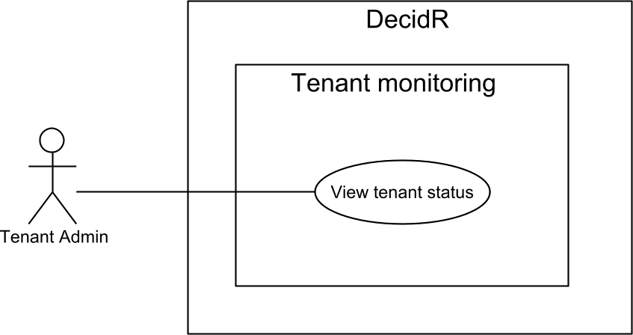
Figure 30 use case overview “tenant monitoring”

View tenant status
Priority | Nice-to-have
Reference | None.
Goal | The tenant admin wants to receive some interesting tenant statistics.
Precondition | The tenant admin is logged in.
Basic flow | - The tenant admin navigates to the tenant status page by selecting “Tenant status” in the navigation menu.  - The system displays the tenant status page containing:  - Number of registered and unregistered users  - Total number of workflow models  - Total number of completed workflow instances  - Total number of aborted / terminated workflow instances
Postcondition | The tenant admin is logged in.  The web browser displays the tenant status page.
Alternative flow | 2a. The tenant has been deleted by the super admin.  3a. The system displays an error message in the web browser.
Alternative postcondition | The web browser displays an error message.

System settings
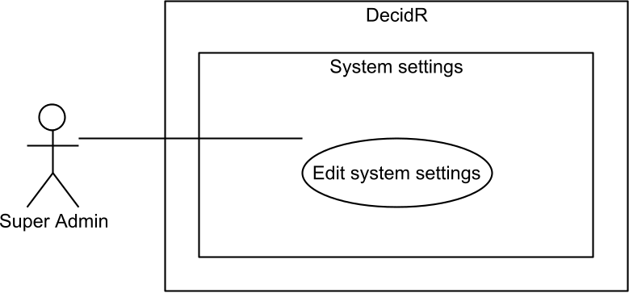
Figure 31 use case overview “system settings”

Edit system settings
Priority | Must-have
Reference | Figure 20 system settings
Goal | The super admin wants to edit the global system settings.
Precondition | The super admin is logged in.
Basic flow | - The super admin navigates to the system settings page by selecting “System settings” in the administration navigation menu.  - The system displays the current settings in the web browser:  - Whether the super admin must confirm all new tenants or they are accepted automatically.  - Amount of logging to perform.  - The super admin enters the new settings.  - The super admin presses the save button.  - The system successfully validates the new settings.  - The system stores the new settings.  - The system displays the updated settings page in the web browser.
Postcondition | The super admin is logged in.  The system has applied the new settings.  The web browser displays the updated settings page.
Alternative flow | 5a. The new settings are invalid.  6a. The system displays an error message in the web browser. The super admin may continue with step 3.
Alternative postcondition | The super admin is logged in.  The web browser displays an error message. The super admin may continue with step 3.

System status
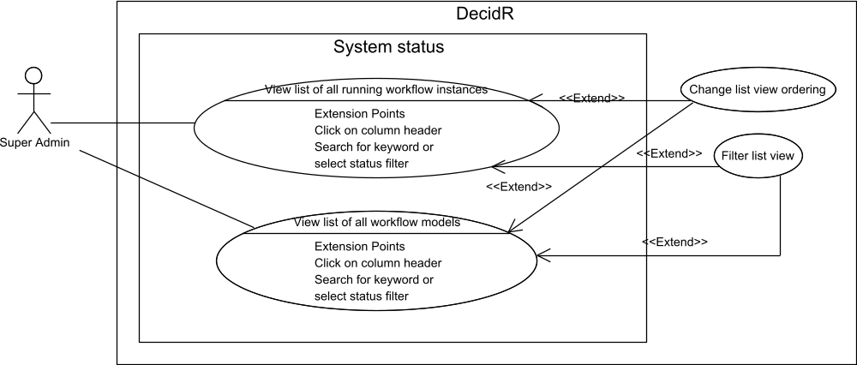
Figure 32 use case overview “system status”

View list of all workflow models
Priority | Nice-to-have
Reference | None.
Goal | The super admin wants to view a list of all workflow models in the system.
Precondition | The super admin is logged in.
Basic flow | - The super admin navigates to the workflow model overview by selecting “Models” in the administration navigation menu.  - The system displays a list of all workflow models coming from all tenants in the system, including the default tenant.
Postcondition | The web browser displays a list of all workflow models.

View list of all running workflow instances
Priority | Nice-to-have
Reference | None.
Goal | The super admin wants to view a list of all running workflow instances in the system.
Precondition | The super admin is logged in.
Basic flow | - The super admin navigates to the workflow model overview by selecting “Instances” in the administration navigation menu.  - The system displays a list of all running workflow instances coming from all tenants in the system, including the default tenant.
Postcondition | The web browser displays a list of all running workflow instances.  The super admin is logged in.

User Management
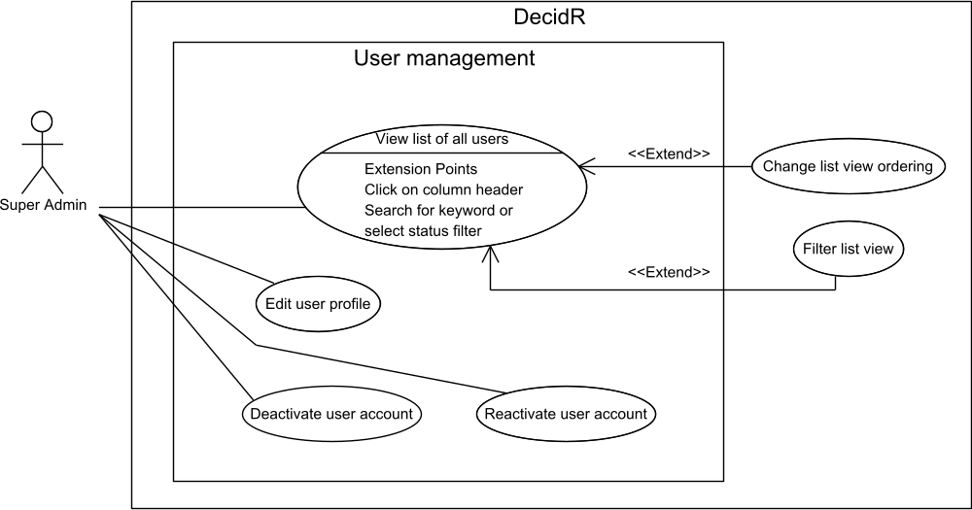
Figure 33 use case overview “user management”

View list of all users
Priority | Must-have
Reference | Figure 21 edit users (super admin)
Goal | The super admin wants to view a list of all users of the DecidR application, including registered as well as unregistered users.
Precondition | The super admin is logged in.
Basic flow | - The super admin navigates to the user list by selecting “Users” in the administration navigation menu.  - The system displays a list of all users in the web browser.
Postcondition | The super admin is logged in.  The web browser displays a list of registered and unregistered DecidR users.

Deactivate user account
Priority | Must-have
Reference | Figure 21 edit users (super admin)  View list of all users
Goal | The super admin wants to deactivate user accounts so the users won’t be able to use the DecidR application until their accounts are reactivated.
Precondition | The super admin is logged in.  There is at least one registered or unregistered user in the system whose account hasn’t been deactivated.
Basic flow | - The super admin navigates to the user list by selecting “Users” in the administration navigation menu.  - The system displays a list of all users in the web browser.  - The super admin selects a number of users to deactivate.  - The super admin presses the deactivate button.  - The system flags each selected user as deactivated.  - The system logs out each selected registered user.  - The system shows the updated user list in the web browser.
Postcondition | The super admin is logged in.  The system has deactivated the selected user accounts.  The system has logged out all selected registered users.  The web browser displays the updated user list.

Reactivate user account
Priority | Must-have
Reference | Figure 21 edit users (super admin)
Goal | The super admin wants to reactivate user accounts so the users will once again be able to use the DecidR application.
Precondition | The super admin is logged in.  There is at least one registered or unregistered user in the system whose account has been deactivated.
Basic flow | - The super admin navigates to the user list by selecting “Users” in the administration navigation menu.  - The system displays a list of all users.  - The super admin selects a number of users to reactivate.  - The super admin presses the activate button.  - The system removes the deactivated flag of each selected user account.  - The system displays the updated user list in the web browser.
Postcondition | The super admin is logged in.  The system has reactivated the selected user accounts.  The reactivated users are once again able to log in.  The web browser displays the updated user list.

Edit user profile
Priority | Desirable
Reference | Figure 8: profile page  6.12.1 View list of all users
Goal | The super admin wants to edit a user profile, possibly because it contains false or illegal information.
Precondition | The super admin is logged in.  There is at least one registered user.
Basic flow | - The super admin navigates to the user list by selecting “Users” in the administration navigation menu.  - The system displays a list of all users.  - The super admin selects the user whose profile should be edited.  - The system displays the current profile of the selected user in the web browser.  - The super admin enters the new profile data.  - The super admin presses the save button.  - The system successfully validates the new profile data.  - The system stores the new profile information.  - The system displays the updated profile of the selected user in the web browser.
Postcondition | The super admin is logged in.  There is at least one registered user.  The system has updated the selected user’s profile with the new data.
Alternative flow | 7a. The new profile data is invalid.  8a. The system displays an error message in the web browser. The super admin may continue with step 5.
Alternative postcondition | The super admin is logged in.  There is at least one registered user.  The system hasn’t modified the selected user’s profile data.  The web browser displays an error message. The super admin may continue with step 5.

Tenant Management
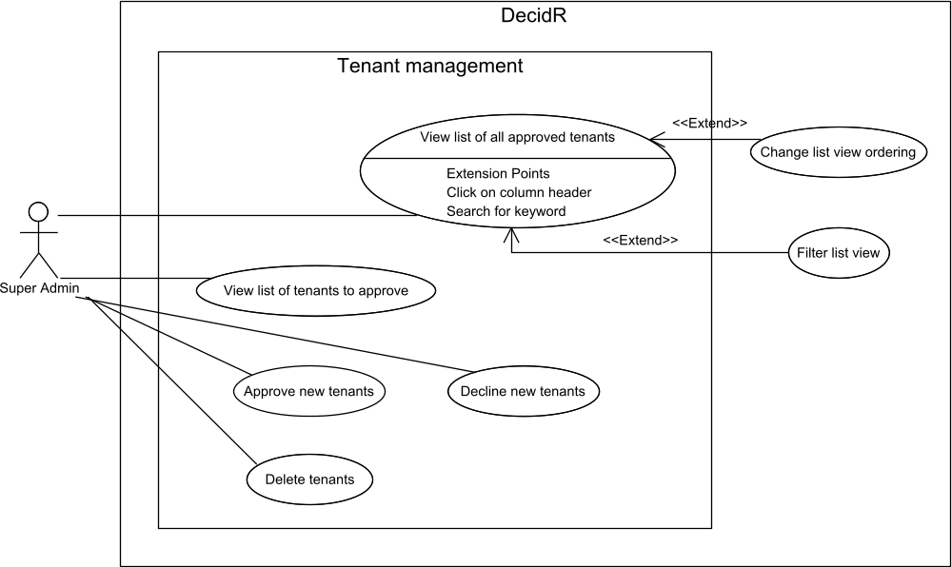
Figure 34 use case overview “tenant management”

View list of all approved tenants
Priority | Must-have
Reference | None.
Goal | The super admin wants to view a list of all approved tenants in the system.
Precondition | The super admin is logged in.
Basic flow | - The super admin navigates to the list of approved tenants by selecting “Approved tenants” in the administration navigation menu.  - The system displays a list of all approved tenants in the web browser.
Postcondition | The super admin is logged in.  The web browser displays the list of approved tenants.

Delete tenants
Priority | Must-have
Reference | Figure 18: edit tenants
Goal | The super admin wants to completely remove a tenant, including its workflow models and workflow instances.
Precondition | The super admin is logged in.  There is at least one approved tenant.
Basic flow | - The super admin navigates to the list of approved tenants by selecting “Approved tenants” in the administration navigation menu.  - The system displays a list of all approved tenants in the web browser.  - The super admin selects the tenants to remove.  - The super admin presses the delete button.  - The system displays a confirmation dialog in the web browser.  - The super admin confirms the deletion.  - The system terminates all running workflow instances of the selected tenants, and then removes the selected tenants and all workflow models and workflow instances of the selected tenants.  - The system displays the updated list of approved tenants in the web browser.
Postcondition | The super admin is logged in.  The system has removed the selected tenants and their workflow models and workflow instances.  The web browser displays the updated list of approved tenants.
Alternative flow (1) | 6a. The super admin cancels the deletion
Alternative postcondition (1) | The super admin is logged in.  The system hasn’t deleted the selected tenants.  The web browser displays the list of approved tenants.
Alternative flow (2) | 7a The super admin is trying to remove the default tenant, which cannot be removed.  8a. The system displays an error message in the web browser.
Alternative postcondition (2) | The super admin is logged in.  The system hasn’t deleted the selected tenants.  The web browser displays an error message.

View list of tenants to approve
Priority | Must-have
Reference | Figure 19: tenant approval
Goal | The super admin wants to view a list of all tenants that need manual approval.
Precondition | The super admin is logged in.
Basic flow | - The super admin navigates to the list of tenants that require approval by selecting “Tenants to approve” in the administration navigation menu.  - The system displays a list of all tenants that need approval and the user that is requesting to become tenant administrator in the web browser.
Postcondition | The super admin is logged in.  The web browser displays the list of tenants that need approval.

Approve new tenants
Priority | Must-have
Reference | Figure 19: tenant approval
Goal | The super admin wants to approve a new tenant so the tenant administrator may begin creating workflow models, changing the tenant settings, etc.
Precondition | The super admin is logged in.  There is at least one new tenant waiting for approval.
Basic flow | - The super admin navigates to the list of tenants that require approval by selecting “Tenants to approve” in the administration navigation menu.  - The system displays a list of all tenants that need approval in the web browser.  - The super admin selects a set of tenants to approve.  - The super admin presses the approve button.  - The system unlocks the selected tenants.  - The system sends an e-mail to each tenant admin telling them about the approval.  - The system displays the updated list of tenants that need approval in the web browser.
Postcondition | The super admin is logged in.  The system has unlocked the selected tenants.  The web browser displays the updated list of tenants that need approval.  The system has sent e-mails telling the tenant administrators about the approval.

Decline new tenants
Priority | Must-have
Reference | Figure 19: tenant approval
Goal | The super admin wants to decline a new tenant.
Precondition | The super admin is logged in.  There is at least one new tenant waiting for approval.
Basic flow | - The super admin navigates to the list of tenants that require approval by selecting “Tenants to approve” in the administration navigation menu.  - The system displays a list of all tenants that need approval in the web browser.  - The super admin selects a set of tenants to approve.  - The super admin presses the decline button.  - The system deletes the selected tenants.  - The system sends an e-mail to each tenant admin telling them about the decline.  - The system displays the updated list of tenants that need approval in the web browser.
Postcondition | The super admin is logged in.  The system has deleted the selected tenants.  The web browser displays the updated list of tenants that need approval.  The system has sent e-mails telling the would-be tenant administrators about the decline.

Misc. Features
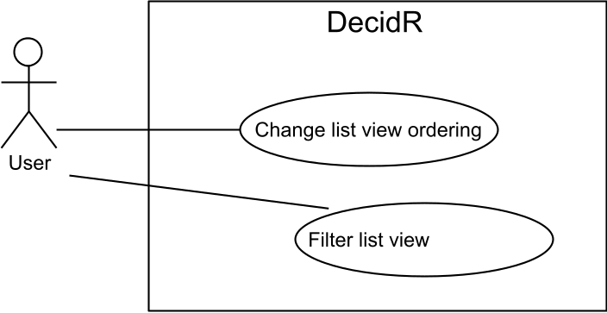
Figure 35 use case overview “Misc. features”

Filter list view
Priority | Must-have
Reference | Figure 17: edit user list (tenant admin)
Goal | The user wants to change the ordering of the list view by a certain column. Available columns depend on the kind of list view that is displayed.
Precondition | The web browser displays a list view of some sort, such as the tenant member list in the user administration. It is currently sorted by some column in ascending or descending order. The user may have applied filters to the list view.
Basic flow | - The user clicks on the header of a column that isn’t currently used to sort the list view.  - The system displays the updated list view, now sorted by the selected column in ascending order.
Postcondition | The web browser displays the updated list view, now sorted by the selected column in ascending order. If the user had previously applied filters to the list view, they still apply.
Alternative flow | 1a. The user clicks on the header of the column that is currently used to sort the list view.  2. The system displays the updated list view, now sorted by the selected column in descending order.
Alternative postcondition | The web browser displays the updated list view, now sorted by the selected column in descending order.  If the user had previously applied filters to the list view, they still apply.

Change list view ordering
Priority | Must-have
Reference | Figure 17: edit user list (tenant admin)
Goal | The user wants to filter a list view by keyword or other filters. Available filters depend on the kind of list view that is displayed.
Precondition | The web browser displays a list view of some sort, such as the tenant member list in the user administration. It is currently sorted by some column in ascending or descending order. The user may already have applied some filters to the list view.
Basic flow | - The user selects a set of filters to apply to the list view from the filters area.  - The user presses the filter button.  - The system updates the list view using the selected filters.
Postcondition | The web browser displays the updated list view, which is still sorted by the same column in the previous order. The system has applied the new set of filters to the list view.

Nonfunctional Requirements

Quantity Structure

User
In the system exactly one super admin exists. The number of users per tenant is not limited.

User Roles
There are no limits to how many tenants a user can administrate, in how many workflows he can take part and in how many workflows he can administrate.

Workflow models / instances
Each tenant can own up to 1000 workflow models. The running workflow instances are limited to 1000 running workflows at the same time. Each workflow instance is administrated by zero or more workflow admins.

File Size
The upload size for human task activities is not limited.

Registration
For each e-mail address only one account can exist.

Tenants
There is no limit to the number of tenants which can exist. Each tenant is administrated by exactly one registered user.

Performance Requirements & Scalability
DecidR needn’t fulfill any kind of higher performance requirements. A key performance indicator is the time between navigating to a web page on the front-end and the moment when the web browser finishes loading that web page and displays its content. This time span should not exceed five seconds.
The system must be designed to scale well, so the performance requirements can be met even with thousands of users using the system concurrently. Scaling the system should be as easy as starting another server instance and updating a few configuration files. Under no circumstance should adding new server instances require changes in source code files.

Safety Requirements
There are no requirements concerning possible loss, damage, or harm that could result from the use of DecidR. In case of data loss, the operator of the DecidR application is not obliged to compensate the tenants for any resulting damage. The safety of the data depends on the used storage systems and services.

Security Requirements
All web services and server components of the DecidR application must be designed to be resilient to attacks. Mechanisms for strong input validation and encrypted communication must therefore be considered during the design phase. Connections to the database must be secured using SSL and X509 certificates with client and server validation.

Password Policy
Users who are registering at the DecidR web site are required to choose a password consisting of at least eight characters. The password must contain at least one non-alphanumeric character. After ten consecutive unsuccessful login attempts, the super admin is informed of the potential brute force attack via e-mail.

Privacy Protection
Since many users use the same password on many sites, DecidR must use an authentication method that does not reveal the password even if an attacker gains access to the database. Connections to the web front-end must be secured using SSL / HTTPS.

Software Quality Attributes

Usability
High usability is a very important requirement. The web-based front-end should provide an intuitive and easily usable interface. Even users with little technical experience must be able to interact with the system. There are no requirements concerning accessibility features for blind or handicapped persons.

Extensibility and Changeability
It is almost certain that development of the DecidR application will continue in a future project with a completely different team. Typical extensions would include internationalization, creating new web services, or adding new elements to the modeling tool. Components that are subject to change include the storage backend and the web site layout.
DecidR must therefore be designed so that changes as well as extensions can be carried out with reasonable effort. Loose coupling and thorough documentation are the two main pillars that make extensions and changes to DecidR possible.

Availability
Failure of a particular web service should not cause the front-end and features that don’t depend on that web service to fail as well. Furthermore, launching additional server instances should increase the availability of the application by making use of the failover options provided by the Synapse ESB.
The project team cannot take responsibility for server outages on the side of the Amazon EC2 or due to bugs in MySQL, Tomcat, Axis2, ODE or Synapse.

Testability
Each developed web service must come with a JUnit test suite for automated unit testing. While it is difficult to provide this for the servlets that make the web front-end, automated tests will be delivered where no user interaction is required to produce meaningful input data. The same goes for the JavaScript-based workflow modeling tool.

Portability
Since the DecidR application is entirely based on Java™ there are no special portability requirements. The application is expected to be deployable in any environment where Tomcat 5.5.x and Synapse 1.2 are executable. The system must be designed to allow exchanging the underlying persistent data storage within a few working days.

Robustness
The system must react in a robust way to invalid user input. This means that the system should react to invalid user input by generating meaningful error messages and mustn’t simply crash. Strong input validation is therefore required in all subsystems.

Business Rules
There are no business roles for DecidR in a true sense, since the application is available to any person that has an e-mail address, free of charge. Instead, this section contains a listing that should prove useful at a later project stage when access control lists need to be defined.

Use Case | Super Admin | Tenant Admin | Workflow Admin | Registered User | Unregistered User
Use Case 1 | X | X | X
Use Case 2 |  |  |  |  | X
Use Case 3 | X | X | X | X | X

Applicable Technologies
The following table lists the version numbers of software and standards that are used by the DecidR application:

Component | Version
Apache ODE BPEL Engine | 1.2
Apache Synapse ESB | 1.2
Tomcat Servlet Container | 5.5.x
Axis2 Web Service Engine | 1.4.2
MySQL DBMS | 5.1.30
JavaServer Pages | 2.0
Servlets | 2.4
Java Runtime Environment | 1.6

